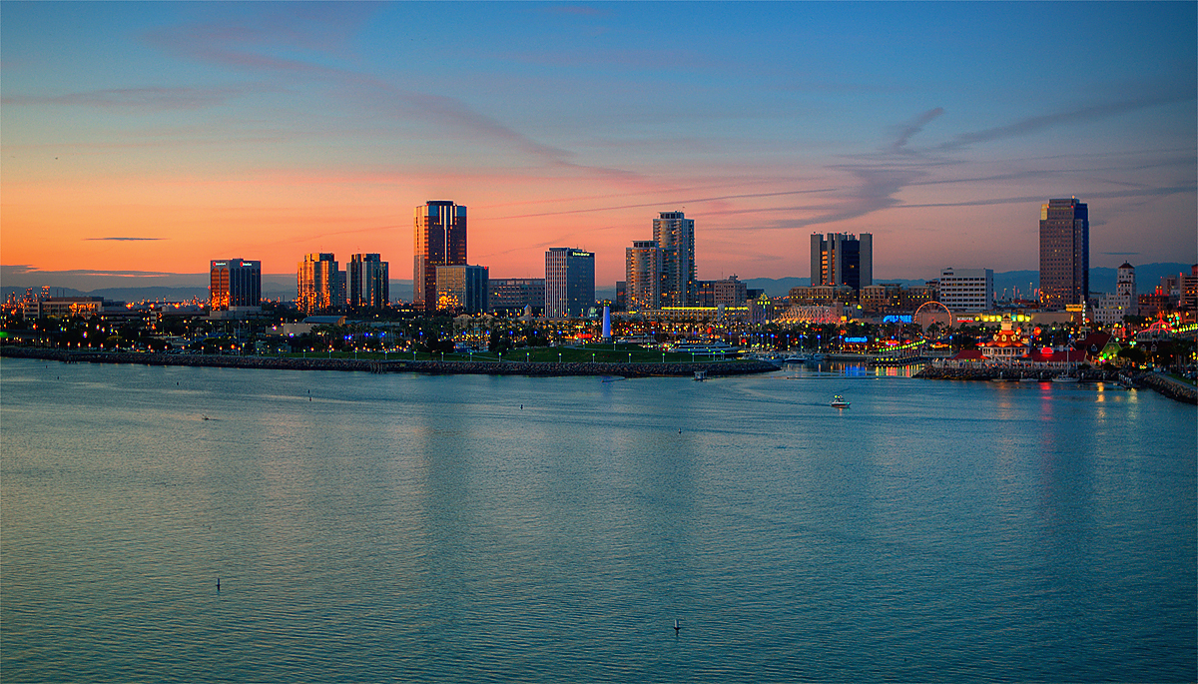

UNIVERSITY OF CALIFORNIA, Santa Barbara

Motivating Water Conservation

in Southern California

through Allocation and Market Mechanisms

A Group Project submitted in partial satisfaction of the requirements for the degree of

Master of Environmental Science and Management for the

Bren School of Environmental Science & Management by

Jim Bond

Mary-Sophia Motlow

Lauren Steely

Dean Wang

Committee in charge:

Dr. Gary Libecap

April 2015

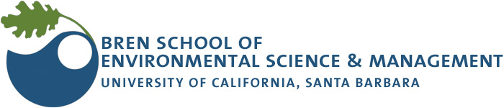

As authors of this Group Project report, we are proud to archive this report on the Bren School’s website such that the results of our research are available for all to read. Our signatures on the document signify our joint responsibility to fulfill the archiving standards set by the Bren School of Environmental Science & Management.

___________________________________

Jim Bond

___________________________________

Mary-Sophia Motlow

___________________________________

Lauren Steely

___________________________________

Dean Wang

The mission of the Bren School of Environmental Science & Management is to produce professionals with unrivaled training in environmental science and management who will devote their unique skills to the diagnosis, assessment, mitigation, prevention, and remedy of the environmental problems of today and the future. A guiding principle of the School is that the analysis of environmental problems requires quantitative training in more than one discipline and an awareness of the physical, biological, social, political, and economic consequences that arise from scientific or technological decisions.

The Group Project is required of all students in the Masters of Environmental Science and Management (MESM) Program. It is a three-quarter activity in which small groups of students conduct focused, interdisciplinary research on the scientific management, and policy dimensions of a specific environmental issue. This Final Group Project Report is authored by MESM students and has been reviewed and approved by:

_________________________________

Gary Libecap

April 13, 2015

Abstract

Despite the ongoing 2012-15 drought, urban water agencies in Southern California have not responded aggressively to statewide calls for conservation. Long Beach Water Department has been an exception, reducing their per capita water usage by 40% through conservation measures over the last 30 years. Why have other urban agencies in Southern California not undertaken similar conservation efforts? We investigate to what extent the Metropolitan Water District’s existing system of drought water allocation provides incentives for agencies to conserve, showing that an agency’s conservation efforts in wet years lead to a lower water allocation in times of drought. We analyze the effect of an individual agency’s conservation on their drought allocation and on other agencies’ allocations, revealing a disincentive to conserve under the current system. In response, we develop an alternative allocation system with the goal of incentivizing conservation. We show that under the new system, agencies are able to gain additional benefits from their conservation by trading conserved water in a market. Agencies with high costs of conservation could pay other agencies to conserve water in order to receive the newly created surplus water. Incentivizing conservation helps to ensure that current supplies will meet demand in the face of increasing scarcity and reduces the need to seek new supply.

Executive Summary

In January 2014, in year four of one of the worst droughts in California history, Governor Jerry Brown declared a state of emergency and urged water agencies throughout the state to voluntarily reduce their use by 20% below 2013 levels. By February 2015, more than a year later, Southern California agencies had only reduced their usage by 2%. With the severity of the drought increasing, Governor Brown instituted a mandatory 25% reduction for urban water users.

Why have these urban water agencies not responded more aggressively to the drought? In this report, we argue that the current system of drought allocation in Southern California could better incentivize agencies to conserve by adopting market-based principles. We then explore the opportunity for alternative water allocation methodologies coupled with a market system that would create stronger incentives for conservation.

During a regional supply curtailment, which may occur in 2015–16, Southern California water agencies receive shares of supply in proportion to their recent historical usage; purchases beyond their share are charged a substantially higher volumetric rate. But using historical usage as a baseline creates perverse incentives: agencies with high per capita usage receive a larger share by continuing their high usage, while agencies that invest heavily in conservation during non-shortage years receive less water when a shortage is declared. Moreover, agencies that use less than their share are unable to store or sell their surplus water, a restriction that results in inefficient water use.

Water markets are one possible solution. Similar to markets for pollution emissions, water markets allow agencies with low marginal costs of conservation to benefit from selling their conserved water to other agencies, who also benefit because the market price of water may be less than their own cost of conservation.

The Metropolitan Water District of Southern California service area represents an ideal platform for such a market because its member agencies share a robust and interconnected water infrastructure. Most trades could therefore be reduced to transfers of paper water rights in which conveyance is not a concern, keeping transaction costs low.

Our client, the Long Beach Water Department, is one Southern California agency that has proactively worked to change water use behavior over the last three decades. Through aggressive water conservation programs, Long Beach has reduced its water use to the lowest it has been since 1958, despite an increasing population. However, when agencies like Long Beach have already reduced its demand, a call for further reduction puts additional burden on them because they have already uncovered the easiest and cheapest opportunities for conservation. In addition, the current system of allocating water supply in Southern California suggests that when supplies become limited, the water supply they are allocated will be reduced even further. The conservation Long Beach has done to date causes them to receive less water in times of drought than if they had not conserved at all.

Our research examines the current method of water allocation in Southern California to better understand the implications of conservation. In this paper we consider two questions:

1. *How does the way water is currently allocated in Southern California encourage conservation?*
2. *How could we develop a new allocation system to promote conservation, and how would the new system compare to the current system?*

The Metropolitan Water District of Southern California (Met) is the largest wholesale distributor of water in the United States, providing water supplies to approximately 19 million people via 26 member agencies. During years when water supplies cannot meet demand, Met institutes their Water Supply Allocation Plan (WSAP), a methodology for allocating water to each agency. In order to examine how the WSAP incentivizes conservation, we worked with member agency data and the spreadsheet Met uses to calculate 2015 WSAP formulas.

The WSAP was assembled using estimates for each Met member agency’s water demand, population, local supplies, per capita usage, and other factors used to calculate the amount of water they can purchase during a drought. The values in the WSAP serve as an approximation for how water would be allocated under the status quo should a shortage be declared. Using the WSAP, we were able to observe how an agency’s water use affects the amount of their individual allocation, and the allocations of other member agencies. Allocation outcomes were then tested for differing agencies, under differing intensities of water use and differing levels of shortage severity.

Examination of the status quo led us to identify two factors in the WSAP that affect incentives for conservation. One factor relates to the baseline period from which an allocation is calculated, and the other relates to the lack of a secure use right associated with an allocation. We found that the WSAP only accounts for an agency’s most recent year’s water use when determining an allocation. As such, the WSAP provides water to anticipate current demand based on the most recent years’ consumption. However, this methodology does not acknowledge the benefits from conservation that agency has provided in reducing demand over time. Furthermore, there is no claim that an agency can make on the quantity of water conserved for later use or trading. Effectively, the conservation efforts of an individual agency benefit the system as whole by providing more water to distribute, but hurt the conserving agency by reducing their demand and therefore the size of their allocation.

We then examined alternative approaches to allocating water that might improve conservation incentives, and compared the results of those strategies with the WSAP analysis results. After reviewing various methodologies of allocation, the pros and cons of each of those distribution mechanisms were considered and we developed a new framework allocation system called the BrenSAP. The BrenSAP method addresses the disincentives for conservation of the WSAP by combining historical use benchmarks, water use targets (as measured in gallons per capita per day, gpcd), and the assignment of shares with associated use rights to promote conservation and efficiently distribute water.

The BrenSAP was also assembled using estimates for each Met member agency’s water demand, population, water use (gpcd), and factors relevant to determining allocation as with the WSAP. Similarly, the BrenSAP was tested for differing agencies, under differing intensities of water use and shortage severity, and the results compared to the previous WSAP testing results.

Testing the BrenSAP revealed that this alternative system of allocation provided incentive for conservation. In using a historical use benchmark from which to establish an agency’s allocation, we created a measuring stick by which to gage water use. Conservation actions over time and the resultant improvements in water use then benefit an agency by creating a surplus quantity of water that may be claimed by the agency as a tradable use right. In addition, the inclusion of associated use rights for the conserved water creates added benefit by creating opportunities for an agency that previously did not exist. For agencies with surplus allocation, they could have the option to sell that surplus to other agencies, store the surplus for future years, or provide that water to new users within the agency service area. Furthermore, given that the opportunities for conservation will vary depending on an agency’s preferred water use, their local conditions and alternative supply options, and their costs of conservation, the use rights associated with an allocation provide an opportunity for an agency to seek conservation through subsidizing another agency at a cost less than they would have to pay had they conserved on their own. Agencies that can conserve more are encouraged to do so and rewarded in profit by those agencies where conservation is more locally cost prohibitive. The alternative allocation method of the BrenSAP therefore motivates conservation, and provides benefits to both individual agencies and the system as a whole.

The available opportunities for trade and subsequent outcomes are dependent upon a number of conditions, rules, and mechanisms to facilitate transactions. Although exploring the outcomes of these different potential market rules was beyond the scope of this project, we concluded our analysis by developing a flow path of critical components and considerations that would need to be addressed to enable trade among Met member agencies.

Our exploration of conservation scenarios illustrates that under the status quo, agencies are better off *increasing* their water demand in advance of a drought in order to secure a larger share of supply during a shortage, rather than conserving water to prepare for when supplies are limited. Ironically, this behavior can actually increase the probability that the system will go into shortage and may also the increase the shortage level forcing Met to secure costly outside supplies. From the perspective of conservation, the BrenSAP system appears to provide a number of advantages over the current WSAP used by Met. The BrenSAP incentivizes conservation, not just in times of drought, but during all supply conditions. As more agencies proactively manage their demand, there is greater potential for Met to avoid instituting a shortage allocation plan, or if they do, reduce the severity of the required reductions.

The BrenSAP allocation system illustrates some of the benefits that could be found in applying a new method for distributing and managing water. However, our process is only a rough sketch for what might be done through allocating water to promote conservation. While we present a conceptual example of how two agencies may interact, a more predictive look at the full range of interaction between all Met member agencies is subject to many complex and highly dynamic variables. The ability of an agency to secure the benefits of their conservation will depend on that agency’s costs of conservation, the other Met member agencies’ costs of conservation, the prices of water established by Met, the design of the allocation system, and the constraints imposed by the market platform structure and conditions of trade.

The alternative system we outline in this document is not intended to be the only possible solution; rather, we hope to stimulate dialogue and creative thinking in how to respond to this issue. Through our research, we identify issues with the current system that appear to limit conservation, review alternatives, and present a logical and reasonable approach to thinking about a specific question, which is how to design an allocation system that promotes conservation. Ultimately, the details of a change to the system will be the result of much more in-depth analysis, and negotiation among the parties involved and affected.

The challenge for Southern California over the next century is to live within its current water supplies even as its population and economy grow. We now find ourselves in a new era of scarcity when water reliability will have to come from better managing our demand. As we design systems to allocate our scarce water supplies, we therefore have to consider the incentives for conservation as a key component. Instituting a system that acknowledges and rewards conservation will therefore be critical to managing our water supplies.

Table of Contents

Abstract iii

Executive Summary iv

Table of Contents x

Table of Figures 12

1. Introduction 13

1.1 Project Description 14

1.2 Significance 15

2. Background 16

2.1 California Drought 16

2.2 The Metropolitan Water District of Southern California 17

2.3 Long Beach Water Department 23

2.4 Motivating Water Conservation 25

3. Methods 29

3.1 Question 1: Analyzing the Status Quo 29

3.2 Question 2: A New Way Forward 31

4. Results 37

4.1 Question 1: Analyzing the Status Quo 37

4.2 Question 2: A New Way Forward 44

5. Discussion 51

5.1 Water conservation under the status quo (WSAP) 51

5.2 Water conservation under the BrenSAP 52

5.3 Benefits of establishing a market for conserved water 53

5.4 Challenges of Allocating Water 55

6. Conclusions 57

7. Acknowledgements 59

8. References 60

9. Appendix A: Charts and Tables 62

10. Appendix B: Alternative Allocation Systems 66

10.1 Preferential Rights 66

10.2 Gallons Per Capita Per Day (GPCD) Benchmark 74

Table of Figures

Figure 2‑1. Southern California water usage, 2014-15 14

Figure 2‑2. Map of the Metropolitan Water District 16

Figure 2‑3. Preferential rights over the last decade for the Met member agencies 17

Figure 2‑4. Location of the Long Beach Water Department 21

Figure 2‑5. Long Beach Water Department per capita water consumption 21

Figure 4‑1. Incentives for conservation under the status quo (WSAP) 34

Figure 4‑2. “Use more get more” and “use it or lose it”. 37

Figure 4‑3. When agencies conserve more, other agencies benefit by receiving larger allocations. 39

Figure 4‑4. Agencies that reduce their gpcd through conservation receive a larger allocation under the BrenSAP than under the 2015 WSAP. 42

Figure 4‑5. Long Beach Met water demand and BrenSAP allocation for varying levels of conservation. 44

Figure 4‑6. When agencies conserve more, they are rewarded with a surplus that can be sold. 45

Figure 4‑7. A market considerations flow path that illustrates the options available for the transfer of allocations among member agencies. 46

Figure 5‑1. Conservation costs for two agencies can be modelled as demand curves that reflect the value of water to each agency 51

Figure 9‑1. Met’s 2015 Supply Allocation Plan. 60

Figure 10‑1. Comparison between the water demanded and allocation provided for a low gpcd agency and a high gpcd allocation 75

# Introduction

I

n January 2014, in year four of one of the worst droughts in California history, Governor Jerry Brown called a press conference to declare a state of emergency. The Governor urged water agencies throughout the state to voluntarily reduce their use by 20%. Yet in the 14 months since this call to action there was only one month where California met its water use target. In March of 2015 Governor Brown responded by instituting a mandatory 25% reduction for urban water users.

California’s three main water supplies are snowpack, surface storage, and groundwater. All three of these sources of water are currently in severe decline. As of April 1st, the 2015 Sierra Nevada snowpack is at 5% of normal, the lowest snowpack level ever recorded. Lake Mead, which supplies a large percentage of surface water storage for Southern California, is also at a record low amount. Furthermore, California recently passed legislation for the management of groundwater supplies, as over 25% of groundwater basins in the state are considered threatened by overdraft and excessive extraction. Now, more than ever, the need for water conservation and wise management of our water supplies is apparent.

While it may be reasonable to ask for conservation in times of drought, the paradox we face is that when supplies are most limited, we often need more. Because so much of the water we use is done so to support crops, lawns, and gardens, when there is no precipitation those needs are more reliant on stored water supplies than in normal years to sustain them. Therefore, without real changes in behavior, the use of our available water increases. We saw this illustrated at times during the summer of 2014, when, despite the governor’s plea, water use in Southern California actually rose from previous years.

Given that reality, implementing conservation in the midst of a drought can be a difficult task. Abrupt changes in water supply call for abrupt changes in water use, which may have serious impacts economically and environmentally. The common expectation is that during these times we must all make sacrifices, and share the burden in a way that hopefully, minimizes the overall impact.

However, an alternative to forcing action only when it is most needed is to do more to plan for and expect these periodic shocks in supply. Changing behavior and reducing long term water use over time will better prepare us for drought, and lessen the impact that is felt when it does occur.

Long Beach is an example of an agency in Southern California that is taking the long view with regard to their water needs. With the implementation of creative and aggressive water conservation strategies over the last few decades, the Long Beach Water Department has reduced their city’s water use to the lowest it has been since 1958, despite an increasing population. However, for an agency like Long Beach that has already made great strides to reduce their demand, a call to reduce even further puts more burden on them because they have already uncovered many of the opportunities to conserve. In addition, the current system of portioning water supply suggests that when supplies become truly limited, as may happen in 2015, the water they receive will be reduced even further. Effectively, the conservation Long Beach has worked so hard to accomplish at the expense of its own residents will be redistributed to benefit others without compensation.

The 2014 drought then raises an interesting question: Why should water agencies like the Long Beach Water Department conserve water when there is seemingly little benefit for them to do so? And further, in environments like Southern California where trends predict longer and harsher droughts in the years ahead, what might be done to motivate a more conscientious water use? How might we more proactively realize the benefits of conservation to insulate ourselves from inevitable shocks in supply?

## Project Description

**The conservation Long Beach has done to date causes them to receive less water in times of drought than if they had not conserved at all.**

Our research examines the current way that water is allocated in Southern California to understand the implications for conservation. In this paper we consider two questions.

### Research Question 1

*How does the way water is currently allocated in Southern California encourage conservation?*

How do an agency’s conservation efforts affect how much water they can purchase from Met under the current system of water distribution, particularly in times of drought?

### Research Question 2

*How could we develop a new allocation system to promote conservation, and how would the new system compare to the current system?*

What outcomes will an alternative allocation strategy have for the Long Beach Water Department and the Met system as a whole?

## Significance

Population growth, scarce water supplies, drought and climate change require Californians to conserve and allocate water efficiently to meet the diverse needs of water users. Our analysis shows that the current water distribution system used by Met actually discourages conservation and encourages increased water consumption as a means to prepare for drought. Our exploration of alternative allocation strategies provides a foundation on which to discuss these issues with the current system, and illustrates the advantages that may result from changing the status quo. Implementing a system that promotes long-term and wide-scale conservation may have profound implications for millions of water users throughout southern California and across the state.

# Background

## California Drought

On January 17, 2014, Governor Jerry Brown proclaimed a State of Emergency in California in response to the ongoing drought. [1] 2013 had ended as the driest year on record, and available water supplies were at levels well below average throughout the state. As part of that proclamation, Governor Brown also urged the state’s water utilities to reduce their water use by 20% below 2013 levels.

Southern California’s urban water suppliers were slow to respond. By summer, 30% of suppliers had not implemented any local water use restrictions. Newspapers reported that usage in Southern California for the month of May had actually *increased* by 8% over 2013.[2] And in July, the State Water Resources Control Board hastened conservation by approving emergency regulations that authorized retail water agencies to fine customers for wasteful uses.[3] Yet as of March 2015, more than a year after his declaration, the Governor’s 20% reduction goal was only met in a single month – December 2014. (Figure 2‑1).[4]

California residents are now experiencing their fourth consecutive year of drought. According to the National Drought Mitigation Center, as of January 2015, 100% of the state is experiencing drought, with roughly 75% experiencing extreme drought, the most severe drought classification. The situation has only worsened since the time of Governor Brown’s proclamation.[5] As a result, Governor Brown recently strengthened his call from voluntary cutbacks to mandatory reductions. In March of 2015 the governor announced a mandatory 25% reduction for all urban water users. As of this writing, it seems likely that Southern California will officially enter into a regional water shortage in 2015, which will put hard limits on the amount of water agencies will have access to. The last regional shortage occurred in 2009.

California droughts are predicted to become more severe, longer-lasting, and more frequent as a result of climate change.[6] If these predictions come true, we will need to be more flexible with how we use water, and more resilient to these changes to limit the impact drought has on us over time. We will need to be creative and thoughtful in how we distribute water and in the ways we recognize and account for where and when conservation gains can be met.

In the sections that follow, we will give an overview of the complex system of water distribution in Southern California and the role of the Metropolitan Water District, as primary provider of water for the region. We will then focus on the ways in which the District allocates water to utilities during regional shortages and examine whether this system may have played a role in how utilities’ respond to drought.

Figure 2‑1. Southern California water agencies did not achieve the Governor’s 20% reduction goal until December 2014, nearly a year later. Data from the State Water Resources Control Board’s Conservation Reporting website (only agencies in the South Coast region are shown here).

## The Metropolitan Water District of Southern California

The Metropolitan Water District of Southern California (Met) is the largest wholesale distributor of water in the United States. Met provides water from the Colorado River and the California State Water Project to approximately 19 million people via 26 member agencies within six Southern California counties. These member agencies are represented by individual city water utilities and local water districts who themselves then distribute water to their customers, with agencies having various dependencies on Met to meet their needs. Met provides roughly 2 million AF per year to its members, supplying water from both the Colorado River Aqueduct and the State Water Project.

Met’s mission is “to provide Metropolitan’s service area with adequate and reliable supplies of high-quality water to meet present and future needs in an environmentally and economically responsible way.” The District was formed by the California state legislature in 1927. As the population and water demand in Southern California has grown, Met’s function as water supplier has also expanded to serve as a steward of regional water resources, managing water conservation, groundwater conjunctive use, desalination, and water recycling projects.[7]

During Met’s first three decades, Southern California enjoyed an era of abundance in which there was always ample water to meet demand. Starting with the droughts of the late 1970’s, however, demand began to exceed supply during especially dry years. In recent years Met has invested in a range of programs to enable it to cope with droughts without having to ration water (known as ‘going into allocation’).[8] These programs include surface storage like the new Diamond Valley Reservoir, groundwater banks, conjunctive use programs, conservation incentives, and options contracts with agricultural districts. Despite these efforts, allocations still occur.

How should Met allocate water between agencies during these shortage years, when supply cannot meet demand? The District has adopted several systems over its history. Originally, the MWD Act described a method, known as preferential rights, that gives agencies use rights to a share of Met’s supply in accordance with how much they have paid into the Met system over their history. This system still has the force of law but has never been put into action. Prior to 1999, Met used an alternative system of uniform rationing, where all agencies were forced to cut back their usage by the same percentage. During the drought and resulting shortages of 2009-2011, Met implemented a new system called the Shortage Allocation Plan, which was intended to function more equitably by distributing water based on each agency’s unique dependence on Met – their *need*. This plan may be deployed again, in revised form, during 2015-16.[9]

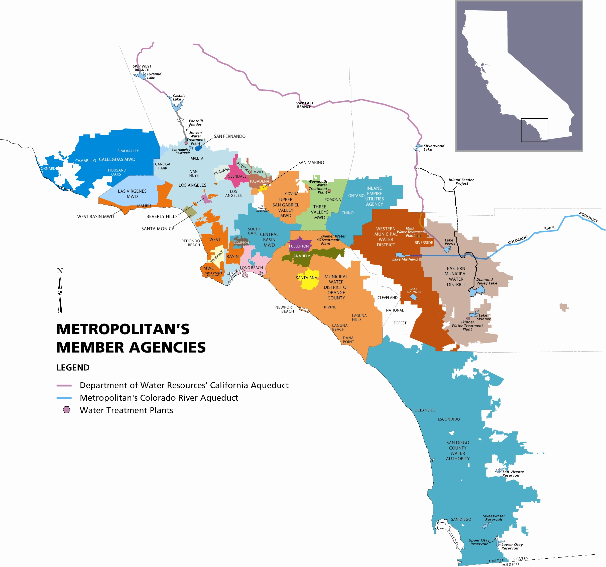

Figure 2‑2. The Metropolitan Water District provides water to 26 member agencies within the Los Angeles—San Diego—Inland Empire metropolitan region. Map courtesy of MWD.

### Preferential Rights

From the 1930s until the 1970s, there was always sufficient water to meet Southern California’s needs, and the member agencies never had to seriously contend with a shortage. The initial system of allocation, known as preferential rights, was established during the early days of Met[10], when the primary concern was ensuring that the 11 founding Met cities obtained a return on their investment in the Colorado River Aqueduct.

Under preferential rights, membership in Met grants use rights to purchase a share of the total available water supply. The amount of water each agency is entitled to purchase annually is based on the ratio of the agency’s historical contributions to Met to the total contributions of all member agencies. Historical contributions include property tax revenues and service fees, but exclude payments for the purchase of water itself. In general, agencies serving larger and wealthier regions contribute more property tax revenue and therefore receive a larger entitlement. Because property tax revenues are much larger than revenues from the other components of preferential rights, urban agencies with large property tax bases receive more preferential rights than smaller or suburban agencies. Over time, as the cost of Met infrastructure has been recouped, Met’s capital and operating costs have become more dependent on revenue from water sales than property taxes.

Although preferential rights have never been invoked, they are important because they serve as a legal backstop for other allocation methods. The fear that an agency may invoke its preferential rights, and thereby dramatically alter how much water each agency receives, serves as a real concern in Southern California water politics.

Figure 2‑3. Preferential rights over the last decade for all 26 Met member agencies (for clarity, only the top five agencies are labelled). The five largest agencies together hold use rights to 67% of the annual supply. Data from Met.

### The Water Supply Allocation Plan (WSAP)

Recognizing the need for an alternative to preferential rights to address water demands under drought conditions, in 2008 Met approved a Water Supply Allocation Plan (WSAP). The plan describes a methodology for distributing water during regional shortages, aiming to distribute reduced water supplies among agencies directly according to their needs.

Under the WSAP, an agency’s allocation is based on their recent water usage, with some credits and deductions to account for past conservation efforts, changes in local water supplies, and other water supply considerations.

Agencies may purchase water up to their allocated quantity at Met’s lowest volumetric price, known as the Tier I rate. They are allowed to purchase water additional to their allocated quantity, but they must then pay an Allocation Surcharge. Thus, the WSAP serves as less of a fixed allocation than a form of price control that encourages demand reduction via a two-tier block rate. In a sense, this system is analogous to “budget-based rates”, a pricing structure used by some retail agencies in which customers are allotted a certain quantity of water based on their historical use, which they may purchase at a low price; water consumed above the allotment incurs a penalty fee.

The WSAP was intended to address some of the concerns raised preferential rights by taking into account each agency’s dependence on Met, though not all agencies considered it equitable.[11] The WSAP does not supersede preferential rights; it is an alternative option to minimize the impact of a drought across all member agencies.

As we will discuss, the WSAP suffers from an issue common to many allocation systems that use historical usage as a strategy: by basing an agency’s allocation on its baseline usage, the WSAP rewards high usage in the past with a larger share during times of drought. Thus there is little incentive in this plan for agencies to conserve during wet years.

The WSAP was last implemented from 2009-11. Recognizing that a water shortage may be imminent in 2015, Met approved an updated 2015 version of the WSAP on December 9, 2014.[12] As of February 2015, it appears likely that Met will vote to approve a shortage level 1 or 2 (a 5-10% reduction) in April.[13]

### Met Pricing

Water suppliers may motivate their customers to conserve by setting volumetric prices to signal resource scarcity. Tiered block rates, a structure in which the marginal price of water increases with increasing usage, are common among retail agencies. Met uses a similar tiered price structure.

The majority of water that Met sells is potable drinking water, also known as Full Service Treated. Full service treated water is priced according to two tiers; 2015 prices for Tier 1 and Tier 2 water are $923/AF and $1055/AF respectively. During non-shortage years, member agencies may enter into a purchase order agreement that specifies a quantity of water the agency will commit to purchase over 10 years. Purchase orders establish a financial commitment from the member agency to Met, and in the process, provide information to Met that they can use to manage supply. With a purchase order, member agencies may purchase up to 90% of their base demand at the Tier 1 rate; additional water may be purchased at Tier 2 rates. Without a purchase order, Tier 2 rates apply to any purchases above 60% of their base demand. Twenty-three of the twenty-six member agencies are under purchase orders. In shortage years, agencies are allocated a smaller quantity of Tier I water, and pay a steeper penalty rate for additional water.

If Met were to declare a shortage and allocate supply, penalties (surcharges) would be applied to with increasing severity as purchases extend beyond an agency’s allocation. In December 2014, Met approved a surcharge of $1,480 per AF for water use between 100% and 115% of an agency’s allocation and a surcharge of $2,960 per AF for water use greater than 115% of allocation.[14]

We argue that Met’s pricing of water during non-shortage years does not create a strong signal that would promote conservation, for two reasons:

1. The Tier I rate applies to almost all (90%) of an agency’s base demand. As such there is little economic signal to reflect the relationship between value and demand.
2. The difference between Tier 1 and Tier 2 rates is small (a 14% increase)., and there is no limit on how much Tier 2 water you can purchase.

During shortage years, the steeper penalty rates may create a stronger price signal, but we argue that the historical usage basis employed by the WSAP to allocate Tier I water minimizes the effectiveness of the penalty rate.

## Long Beach Water Department

LBWD provides water to approximately 462,000 people across a service area that approximately corresponds to the municipal boundaries of the City of Long Beach (Figure 2‑3). LBWD purchases about 40% of their supply from Met, with the balance coming from local groundwater and recycled wastewater.

LBWD conducts one of the most progressive water conservation campaigns in Southern California. Through initiatives like their Lawn-to-Garden turf replacement program, public awareness campaigns, and water use restrictions, the department has created long-term reductions in water use since the 1980s. Water use efficiency is often measured in gallons per capita per day (gpcd), the average amount of water used per person in one day (unless otherwise specified, this includes both water used directly in the home and water used indirectly by commercial and industrial activities). Long Beach succeeded in reducing their water use from 177 gpcd in 1983 to 110 gpcd in 2014; the average water consumption in Southern California is currently over 180 gpcd (Figure 2‑4).[15] Much of the recent reduction occurred during the 2008-9 drought, when a regional water shortage forced the Met agencies into allocation.

The actions of Long Beach residents illustrate the success that LBWD has had in preparing their customers for future drought. In July 2014, total water use in Long Beach was at its the lowest point since 1958, when the city had 150,000 fewer residents, and was 21% below the city’s 10-year historical average.[16] August 2014 was another record-breaking month, coming in at 23% below the city’s 10-year historical average.



Long Beach Water Department’s

service area

Figure 2‑4. The Long Beach Water Department provides water to nearly half a million customers throughout a service area that approximately corresponds with the borders of the City of Long Beach.

Figure 2‑5. Long Beach decreased their per capita water consumption by 40% from 1983 to 2011. Much of the recent decrease occurred during the 2008-9 drought. Data from LBWD.

## Motivating Water Conservation

Water suppliers have a variety of tools to motivate their customers to conserve. Public appeals urge users to voluntarily reduce their consumption, identify inefficiencies and correct them, and consider the needs of other users. While appeals may generate some water savings, it places the burden on individuals to evaluate their own use and make sacrifices to benefit others, while bearing the cost of changes to their water use or implementing conservation measures on their own. However, without a personal incentive for conservation, reducing demand for water is unlikely to be met through good-will alone.[17]

One alternative is regulation: Water suppliers and governments can mandate conservation through restrictions on use, rationing, taxes, or penalties. In this way, the incentive is to avoid the cost of incurring the taxes, penalties, or dependence on the percentage of water that would be reduced through rationing or restriction. Enforcing and administering these regulations often come at a large cost to the overseeing institution, and regulations may also disproportionally impact certain water users.

Another alternative is for the water distributors to adjust water prices to better reflect the value to the user. For example, under such a scenario, the cost of water per unit rises with increasing volumes used. The price of water can provide a powerful incentive to conserve, but water retailers in California are limited in their ability to adjust prices due to legal, financial and political considerations. A substitute to managing demand through pricing is then is to encourage changes in behavior through subsidization. Agencies offer rebates for customers who replace lawns with drought-tolerant landscaping or purchase efficient toilets and showerheads. Demand is then reduced, but at little to no cost to the end user.

Water markets are one incentive-based solution that has received a growing amount of attention across the West. In a market system, users who find efficiencies and reduce their use are able to sell the generated surplus, and those users who consume more do so at a cost that better reflects the value of the resource. Markets match buyers and sellers and allow the resource to be more efficiently directed to the demands of participants in the market, but in a market system, the supply must be limited, and sellers must have a secure and transferable privilege to water.

Similar to markets for pollution emissions, water markets allow agencies with low marginal costs of conservation to benefit from selling their conserved water to other agencies, who also benefit because the market price of water may be less than their own cost of conservation. In a market for conserved water, the seller makes water available by decreasing their need for water. For example, a municipal water agency may implement a turf replacement program. They can then sell the water to another agency at a price that is (hopefully) higher than their cost to conserve the water; this profit motive creates an incentive for further conservation. The purchasing agency benefits as well, since the market price of water may be lower than their marginal cost of conservation.

Water users with a low marginal cost of conservation will tend to be sellers in the marketplace; those with higher marginal costs will tend to be buyers. Much like cap and trade markets for pollution emission credits, the water market efficiently allocates conservation to those who can most afford to conserve, and it encourages conservation by every user over the long run.

A potential new way to manage water in California would be the creation of an urban-to-urban market for conserved water. The Metropolitan Water District of Southern California service area represents an ideal platform for such a market because its member agencies share a robust accounting system and interconnected water infrastructure. Therefore, trades could occur as transfers of allocations. The transfers would then be reported to Met, who would distribute the appropriate quantities of water accordingly, keeping transaction costs low. Such an approach could serve as an exemplary model of how to establish a large-scale urban-to-urban water conservation market.

# Methods

Below we discuss the methods used to answer the two research questions described in Section 1.1.

## Question 1: Analyzing the Status Quo

*How do an agency’s conservation efforts affect how much water they can purchase from Met under the current system of water distribution, particularly in times of drought?*

In order to understand how the conservation efforts of the Long Beach Water Department affect their water allocation, we examined Met’s current Water Supply Allocation Plan.

We obtained an Excel spreadsheet version of Met’s 2015 WSAP formulas from the Long Beach Water Department. The WSAP spreadsheet we acquired was prepopulated with preliminary estimates[18] for each Met member agency’s water demand, population, water use (in gpcd), and factors relevant to determining allocation under the WSAP. The values provided in the WSAP serve as an approximation for how water would be allocated under the status quo should a shortage be declared in 2015.

The WSAP spreadsheet makes it possible to examine allocation volumes for different shortage severity levels. The shortage level indicates a corresponding percent reduction to an agency’s allocation. Each increment in shortage level represents a 5% decrease in allocation. A level 2 shortage (10% reduction) was selected as the baseline for comparison based on the projected shortage level for 2015 announced by Met at the time of this analysis.[19] Although the WSAP accounts for all water needs by an agency, our analysis focuses on only municipal and industrial (M&I) allocations, assuming seawater barrier and replenishment water demands are not uses where conservation could be pursued.

The WSAP spreadsheet was then used to model hypothetical increases and decreases in conservation at an individual agency level to simulate how these changes in behavior would alter allocations. Then the cumulative effect of increased and decreased conservation by multiple agencies to the Met system as a whole was also modeled. The hypothetical scenario allocations were then compared to allocations for existing conditions.

### Individual Agency Behavior Scenario Modeling

To examine the effects of conservation on water allocation at the individual agency level, we selected three agencies with high, medium, and low per capita usage (gpcd, or gallons per capita per day) to test how allocations may differ according to water usage.

The system-wide average for Met is 168 gpcd.[20] LBWD, with a gpcd of 111, was selected to represent a low gpcd agency, the Municipal Water District of Orange County (MWDOC) at 169 gpcd was selected to represent an average gpcd agency, and Eastern Municipal Water District (EMWD) at 235 gpcd was selected as a high gpcd agency. For each agency-type, the WSAP allocation was calculated for a hypothetical 10% increase and 10% decrease in retail demand from the existing condition scenario.

### Met System-Wide Behavior Scenario Modeling

We simulated the impacts that an aggregate increase or decrease in water demand would have on the WSAP shortage level, in order to observe how region-wide changes in demand affect both conservation behavior and the supply available to the overall Met system as a whole.

For these scenarios, agencies with a gpcd over 225 were selected to simulate conservation efforts. These agencies (Test Agencies) include the City of Beverly Hills, Eastern Municipal Water District, Inland Empire Utilities Agency, Las Virgenes Municipal Water District, City of San Marino, and Western Municipal Water District of Riverside County.

Our selected test agencies do not necessarily indicate that these agencies should or are likely to increase conservation. Test agencies were selected solely due to the structure of the Excel spreadsheet and the ease by which multiple sensitivity analyses could be quickly performed by applying an Excel formula.

#### Aggressive Conservation Scenario

The “aggressive conservation” scenario simulates what would happen if the Test Agencies increased their conservation efforts from the existing condition.

The conservation increase was simulated by decreasing the Test Agencies’ water demands such that total demand from Met would now only exceed supply by 5% rather than 10%. This means that the WSAP shortage severity level can be downgraded from level 2 to level 1. Under this scenario, if the shortage level was left at level 2, 5% of the available Met supply would not be allocated. A gpcd reduction of 14.7% was the level of conservation used to retain the same amount of water allocated by Met with a level 1 shortage as the amount of water that would have been allocated under level 2 shortage without the additional conservation. Maintaining consistent Met total supply quantities was necessary to properly compare individual agency allocations between the aggressive conservation scenario and the existing conditions scenario.

#### Increased Use Scenario

The “increased use” scenario simulates what would happen if the same Test Agencies as under the “aggressive conservation” scenario had increased demand rather than decreased use through conservation efforts. Water demand for the Test Agencies was increased by 13.5% to retain the same amount of water allocated by Met under shortage level 3 as would be allocated with a level 2 shortage without the increased use. As with the aggressive conservation scenario comparisons, maintaining consistent Met total supply quantities was necessary to properly compare individual agency allocations between the increased use scenario and the existing conditions scenario.

### Conservation Demand Hardening Adjustment

Our final review of the WSAP compares how much water agencies have conserved against the conservation credit value that is given by the WSAP for conservation demand hardening. Conservation hardening refers to the ability of an agency to conserve, in light of past conservation efforts already completed. The more conservation an agency has conducted, the more difficult it is for an agency to conserve. The WSAP includes a conservation demand hardening to adjust an agency’s allocation. We compared the amount of water an agency has conserved to the amount of allocation adjustment credit given by the WSAP for each of the ten WSAP shortage levels and reviewed the results for individual agencies and from a Met system-wide perspective.

## Question 2: A New Way Forward

*Can we develop a new allocation system that promotes conservation, and how would the new system compare to the current system?*

Examination of the status quo led us to identify two major factors in the WSAP that affect incentives for conservation. One factor relates to the baseline reference period from which an allocation is derived, and the other relates to the lack of a secure use right associated with an allocation.

We then examined alternative approaches to allocating water that might improve conservation incentives, and compared the results of those strategies with the WSAP analysis results. Three methods of allocation were explored: Preferential Rights, Modified Preferential Rights, and gpcd-based Water Use Efficiency allocation. Descriptions and details on each of these approaches are provided in the Appendix.

### Developing the BrenSAP

After reviewing the pros and cons of each of the above allocation mechanisms, we developed a new hybrid allocation system called the BrenSAP. This method combines historical use benchmarks, water use targets (in gpcd), and the assignment of shares with associated use rights to promote conservation and efficiently distribute water. The BrenSAP allocation process is described below.

#### Establish Benchmarks

Historical benchmarks for each member agency’s water demand from Met were established based on agency gpcd and local supply contributions provided in the WSAP. WSAP benchmark gpcds are derived from a formula used by Met to determine historical demand based on a consecutive 10-year average, with an endpoint year between 2004 and 2010. For agencies that did not have benchmark gpcd’s provided in the WSAP, benchmark gpcd’s were assumed from 2010 gpcd data provided in that agency’s 2010 Urban Water Management Plan.

#### Calculating BrenSAP Allocation

1. Calculate what each individual agency demand for Met water would be today if gpcd and local supply had not changed from benchmark
$$Benchmark Demand=\left(Benchmark GPCD × 2015 Population × conversion to AF\right) – Benchmark Local Supply$$

2. Sum all agency demand and calculate percentage for each agency relative to the total aggregate demand.
3. Multiply percentage share for each agency by the total available Met supply for the allocation year (2015).

#### Determining lifeline allocation, benchmark allocation, and surplus/deficit

The BrenSAP partitions an agency’s allocation into tiers. The first tier, which we call the Lifeline Allocation, provides a minimum guaranteed allotment of water. This water would be available at the lowest cost and is intended to ensure a minimum allocation to satisfy basic agency water needs. The BrenSAP provide each agency with 100 gpcd of lifeline water. This amount was described as a minimum allocation target in the 20x2020 urban conservation legislation,[21] and is also already guaranteed to every agency by the existing WSAP.[22]

The next tier of Benchmark allocations provides additional water for uses such as landscape irrigation, commercial, and industrial water. The Benchmark allocation provides water corresponding to the agency’s benchmark year water use rate, at a price reflective of the revenue requirements of Met. As with the WSAP, water demanded in excess of the benchmark allocation may be available, but that water would include a significant surcharge.

1. Lifeline demand is 100gpcd * 2015 population.
   * Any local supplies for agency count towards satisfying lifeline demand first.
     + If local supply exceeds lifeline demand, then no lifeline allocation from Met, and extra local supply carries over into determining benchmark allocation
     + If local supplies < lifeline demand, then remaining lifeline demand is allocated by Met, regardless of share % determined allocation (step 3)
2. Benchmark allocation is total allocation calculated in step 3 minus lifeline allocation from step 4
   * If an agency’s benchmark allocation is greater than their remaining demand, they have a surplus
   * If an agency’s benchmark allocation is less than their remaining demand (including negative), then they will have a deficit

#### Comparison of BrenSAP Allocation to WSAP Allocation

The WSAP allocations to agencies for all levels of shortage were documented. The BrenSAP model was then used to allocate the same total amount of water as would be available under each WSAP shortage level. The BrenSAP allocations were then compared to the WSAP allocations.

The following values were used to model the BrenSAP allocation:

* Existing condition gpcd for each agency was set to the same gpcd as used for the WSAP.
* Local supply quantities for each agency were retained from the benchmark year to the allocation year to explicitly compare the effects of conservation. .
* Values from the WSAP were used for allocation year gpcd, population, retail demand, and local supply to facilitate the comparison of the WSAP allocations to BrenSAP allocations.

### Testing the BrenSAP

Similar to the analysis for the WSAP, the BrenSAP model was used to test the effects of an individual agency increasing or decreasing conservation as well as the cumulative effects of multiple agencies increasing or decreasing conservation. The same agencies were tested for the BrenSAP as for the WSAP so that a direct comparison could be made between the two.

#### Individual Agency Behavior Scenario Modeling

The effects of conservation behavior on an individual agency’s BrenSAP allocation was modeled using the Long Beach Water Department (Long Beach) as an example. The allocation year gpcd for Long Beach was increased by 10% and decreased by 10% to simulate what would happen to the BrenSAP allocation for Long Beach if it had conserved more or less than existing conditions. The impacts to the Long Beach BrenSAP allocation for increased conservation, existing conditions, and increased use were all analyzed for shortage levels 0-10.

#### Met System-Wide Behavior Scenario Modeling

Agencies with a gpcd over 225, the same test agencies we tested in the WSAP analysis, were used to simulate the aggregate effects of multiple agency increases and decreases in conservation. As before, the gpcd for these agencies was increased by 13.5% and decreased by 14.8%. The effects of these changes in these agencies’ gpcd were analyzed for a total allocation equivalent to a WSAP Level 2 shortage allocation.

### Analyzing the Potential Market for Allocations

#### Market Considerations

Under current Met rules, language exists that permits trade of purchased water among agencies, although without a form of use right assigned to the allocation this allowance has little application. However, if an allocation included defined and transferable use rights to purchase water, a market system would enable agencies to gain additional benefits from conservation efforts. The BrenSAP assumes that agencies with a surplus would have the opportunity to sell their surplus. However, the available opportunities for trade and subsequent outcomes are dependent upon a number of conditions, rules, and mechanisms to facilitate transactions. Although exploring the outcomes of these different potential market rules was beyond the scope of this project, we developed a flow path of critical components and considerations that would need to be addressed to enable trade among Met member agencies.

The questions that drive the flow path considerations include:

1. From whose perspective is the market operating; is the actor in the market an agency with a surplus or a deficit?
2. What is being traded; an allocation, purchased water from Met, or delivered water from Met?
3. What options are available to an agency with a surplus? Can an agency store their surplus water?
4. What options are available to an agency with a deficit?
5. What is the mechanism for matching buyers and sellers in the market, and who administers transactions?
6. What are the price bounds on water for sale on the market?
7. How do water and money move after the sale?

# Results

This section details the results from our two major research questions. The results from our analysis of the existing water supply allocation plan (WSAP) and the testing of our proposed BrenSAP are presented below.

## Question 1: Analyzing the Status Quo

The WSAP is a complicated allocation method that incorporates a large number of components to intricately derive an agency’s allocation. Through our initial review of the WSAP, we developed a visualized representation to help understand how each of the components is used and the relative effect of each component in determining the allocation. A full diagram of the WSAP components is provided in Appendix A, but for the purposes of specifically analyzing the incentives for conservation, we have reduced the WSAP to the simplified diagram in Figure 4‑1.

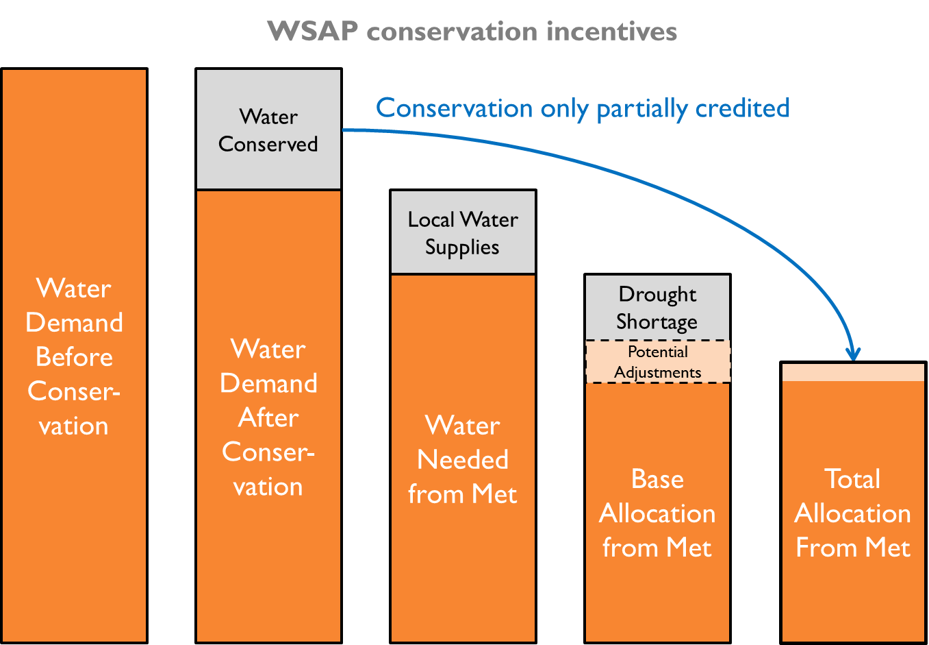

Figure 4‑1. Incentives for conservation under the status quo (WSAP).

It was found that the more an agency conserves under the WSAP, the smaller its allocation will be. For a simplified explanation of the components of the WSAP directly pertinent to conservation:

* + - 1. The first component to consider is how much water an agency needed to meet its demands in the past.[23]
      2. If an agency has implemented conservations since then, water demand for the agency will be reduced.
      3. Most agencies have local water supplies, so the water needed from Met is only a portion of an agency’s total water demand.
      4. When drought occurs and Met supplies are insufficient to meet all water demands, the WSAP is used to determine how much each agency’s allocation will be reduced from its demand. Each shortage level of the WSAP corresponds to a percentage reduction with potential credits/adjustments to accommodate for special circumstances from agency to agency.
      5. The adjustment for conservation however, only credits a small fraction of the total amount of water actually conserved by an agency. The more an agency conserves the less water they get, whereas if agencies do had not conserved, their allocations would have been larger.

### Conservation Demand Hardening Adjustment

The WSAP does not actually provide a credit for the direct conservation done by an agency, but instead, the WSAP attempts to account for the water demand “hardening” an agency might experience as a result of its conservation efforts. This is why even under the most severe shortage level, where the maximum potential adjustments are given, the conservation demand hardening adjustment still only credits agencies for 33% of the water they conserved.

Table 4‑1. Conservation demand hardening adjustment compared to water conserved.



### Status Quo Allocations

The WSAP model was used to calculate an allocation for each of the member agencies to provide a general reference for current distribution of water under the status quo. A level 2 shortage, equating to approximately 10% shortage was used to serve as the baseline for analysis. (Individual agency WSAP allocation results are provided in Table 9‑1 in Appendix A.)

### Individual Agency Behavior Scenario Modeling

The WSAP was used to model what the effects to an agency would be if it increased or decreased the amount of conservation it had undertaken. The results of testing a 10% increase and a 10% decrease in gpcd on individual agency allocations under the WSAP yielded results that are not favorable for incentivizing conservation.

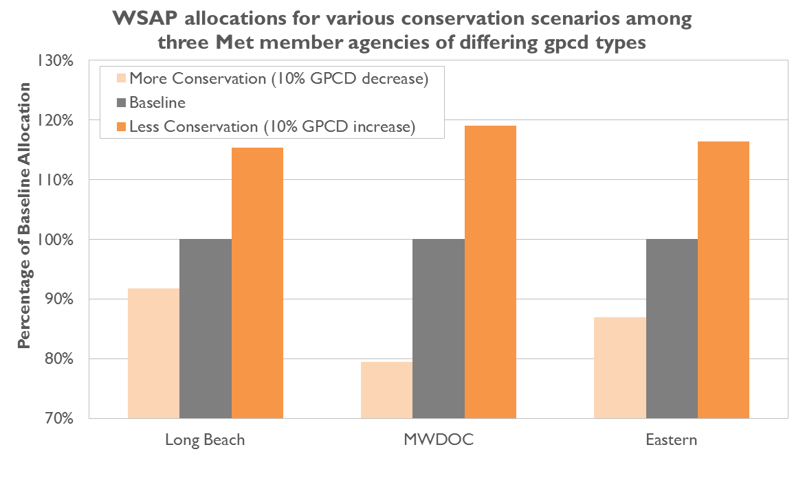

Figure 4‑2. “Use more get more” and “use it or lose it”.

The more water an agency uses, the more allocation the WSAP gives, and if an agency conserves and uses less water, it loses that water under the WSAP.

Testing of the WSAP showed that while other factors such as percentage dependence on Met could affect the magnitude of the result, all agencies received a smaller allocation for conserving water and a larger allocation for using more water.

#### Starting water use does not impact allocation

The magnitude of the WSAP allocation adjustment is the same regardless of whether an agency has a low, medium, or high water use. This means that allocations for agencies that are already efficient with their water use are required to cut back the same as agencies that are not as efficient with their water use; the allocations for an agency with 300 gpcd and an agency with 150 gpcd will both be reduced by the same percentage.

Only when the allocation for an agency drops below the 100 gpcd threshold does the WSAP make a significant accommodation for low gpcd agencies.[24] The WSAP ensures that an agency will not receive less than 100 gpcd if it has a retail demand exceeding 100 gpcd. However, if an agency has retail demand less than 100 gpcd, such as Compton, then the WSAP will only allocate the amount demanded.

The percentage change in allocation was also greater than the simulated 10% change in demand due to conservation or lack thereof. The only exception to the change in allocation being more than 10% was for LBWD (low gpcd agency) when it conserved more and decreased gpcd. In this case, the reduction to allocation for LBWD was only reduced by 8% due to the 100 gpcd minimum allowance rule in the WSAP. Aside from the smaller change in allocation due to the 100 gpcd minimum, the changes in allocation were similar across all gpcd groups.

### Met System-Wide Behavior Scenario Modeling

The results of modeling the aggregate system-wide effects of a water use reduction or increase by multiple agencies revealed that the SAP provides a larger water allocation and financial benefits to non-conserving agencies while conserving agencies receive a smaller allocation. This result is the same as the individual agency modeling results, except with one additional significant outcome: the behavior of individual agencies can increase or decrease the level of shortage for the entire system. Therefore, under the status quo, agencies are benefited or harmed by the actions of other agencies.

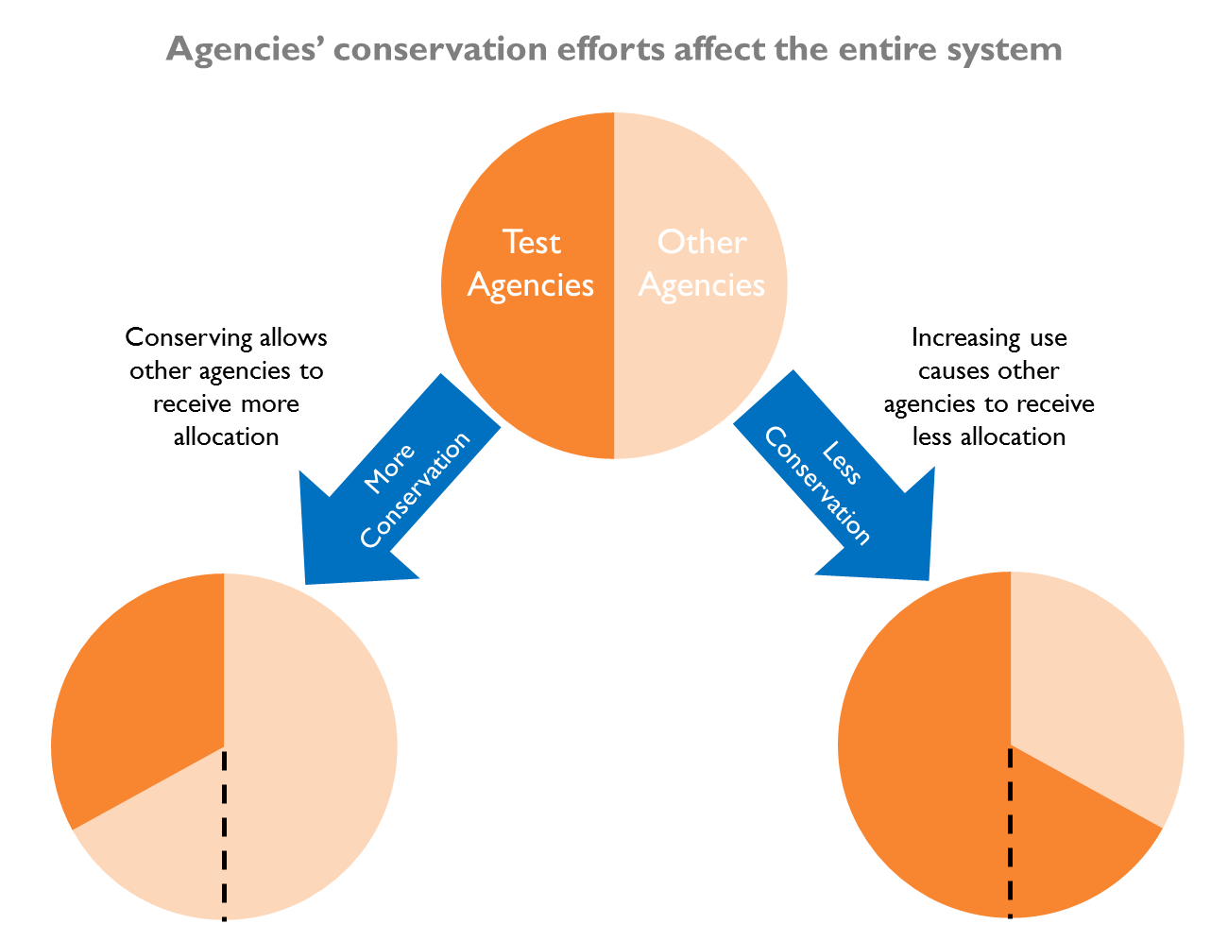

Figure 4‑3. When agencies conserve more, other agencies benefit by receiving larger allocations. When agencies use more water, other agencies receive smaller allocations.

#### Aggressive Conservation Scenario

When multiple agencies engage in conservation, the reduced water demand of those agencies allows Met to declare a less severe level of shortage than it would have had to if those same agencies had not conserved. The conserving agencies bear the costs of conservation and either lose revenue from reduced water sales or have to increase rates for their own ratepayers. Conserving agencies are essentially voluntarily forgoing allocation at their own[25] expense while non-conserving or lesser-conserving agencies reap the benefits.

Non-conserving agencies are able receive a larger allocation than they would have if the other agencies had not conserved. This occurs because the reduction in water demand by the conserving agencies means that there is now less of a discrepancy between water demand and the drought-constrained water supplies, so therefore less of a reduction is needed to scale total demand down to equal available supply. The lessened reduction means that the non-conserving agencies are benefitted and receive a larger allocation unrelated to their own actions.

#### Increased Consumption Scenario

When multiple agencies increase their water demand rather than conserve, the increased water demand of those agencies forces Met to have to declare a more severe level of shortage than it would have had to if those same agencies had conserved. The increase in water demand means that there is a larger discrepancy between water demand and the drought-constrained water supplies, so therefore more of a reduction is needed to scale total demand down to equal available supply. The agencies increasing their water use do so at the expense of all other Met member agencies, which will now experience a larger allocation reduction than they would have if more conservation occurred.

## Question 2: A New Way Forward

### Comparison of BrenSAP Allocation to WSAP Allocation

Total Met allocations under the BrenSAP were calculated to match the total 2015 WSAP allocations under all levels of shortage (Shortage level 1 equals a 5% reduction in demand, level 2 equals a 10% reduction, etc.). Since the total amount of water allocated amount was intentionally set to be the same between the WSAP and BrenSAP for all shortage levels, the only difference was how the total supply would be distributed among agencies.

#### Incentivizing conservation

Since the BrenSAP is designed with the specific goal to promote conservation, we examined how the amount of conservation an agency achieves (measured in percent reduction in gpcd) relates to the allocation benefits it receives under our system (Figure 4‑4).

Agencies were ranked according to how much their allocation increased percentage-wise under the BrenSAP. Similarly, agencies were ranked by the gpcd reduction that they achieved from the baseline year (2008) to the current allocation year (2015). We find a positive correlation between the amount of conservation an agency achieves and how much it benefits from the BrenSAP allocation.

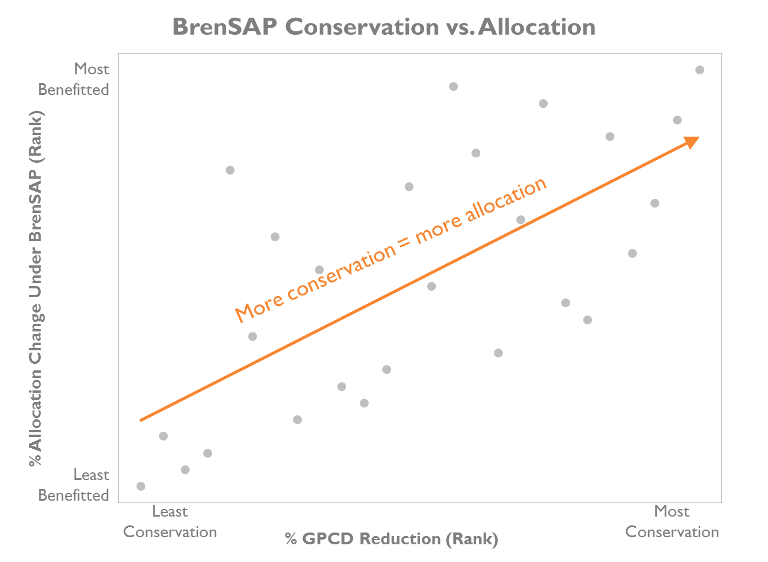

Figure 4‑4. Agencies that reduce their water use through conservation, as measured by gallons per capita per day (gpcd), receive a larger allocation under the BrenSAP than under the 2015 WSAP.

#### Political feasibility

The allocation of any resource inherently means that the process will inevitably benefit some parties and disenfranchise others. Therefore, an important factor in developing a new allocation system is to understand who the winners and losers will be.

The data we used to model the WSAP and BrenSAP are known to be estimates, so we performed this analysis knowing that the votes from agencies that would actually be benefitted could be slightly different. Nonetheless, the goal of this analysis was to determine whether it could be politically feasible for a new allocation system to be approved based on the agencies that would be benefitted.

We find that for ten of the eleven shortage levels, the BrenSAP allocation benefits agencies representing more than 50% of the Met Board votes.

Table 4‑2. For each shortage level, shown are the percentage of votes on the Met Board of Directors held by agencies that fare better under the BrenSAP than the WSAP. Under most shortage levels, agencies that benefit under BrenSAP would have majority voting power.



### Testing BrenSAP Conservation Incentives

#### Individual Agency Behavior Scenario Modeling

We modeled the effect of a 10% increase and 10% decrease in gpcd on Long Beach’s BrenSAP allocation. The results demonstrate that the allocation Long Beach receives under the BrenSAP remains the same with increased or decreased conservation. Although the allocation does not change, conservation reduces the amount of water Long Beach would need to satisfy its demand and therefore changes the allocation surplus or deficit that Long Beach would experience.

Compared to the status quo, adopting more conservation would provide Long Beach with a larger allocation surplus or smaller allocation deficit under the BrenSAP for all shortage levels. Conversely, increasing water usage per capita by 10% compared to the status quo would result in larger BrenSAP allocation deficits under all shortage levels.

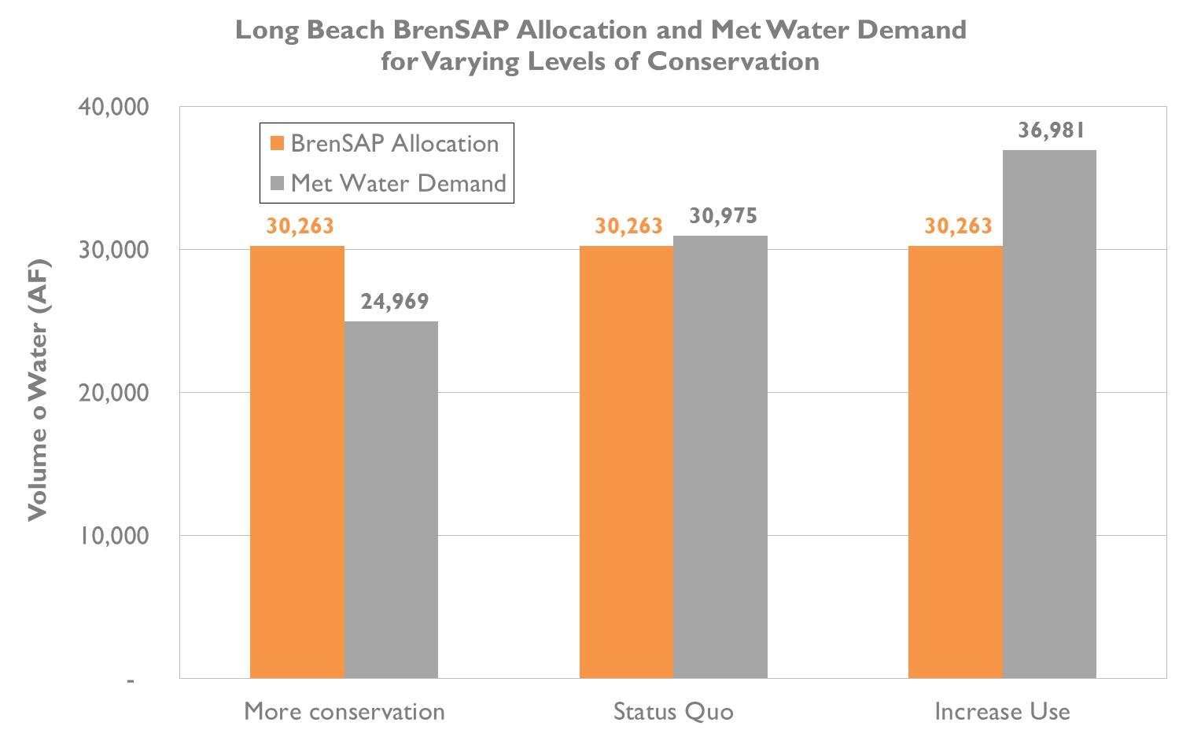

Figure 4‑5. Long Beach Met water demand and BrenSAP (level 2 shortage) allocation for varying levels of conservation.

These results align with our expectations of how we designed the BrenSAP to provide an incentive for agencies to conserve as well as providing a disincentive to increase per capita water usage.

#### Met System-Wide Behavior Scenario Modeling

The results of testing the effects of multiple agencies conserving more or less on BrenSAP allocation were the same as for testing Long Beach individually. While the BrenSAP allocation does not change based on conservation, the amount of water demanded does change, resulting in an allocation surplus or deficit.

Whereas previously under the WSAP agencies that conserved were harmed and agencies that increased usage were benefitted, the BrenSAP has flipped the incentives such that conserving agencies are now rewarded and agencies increasing their use are not.

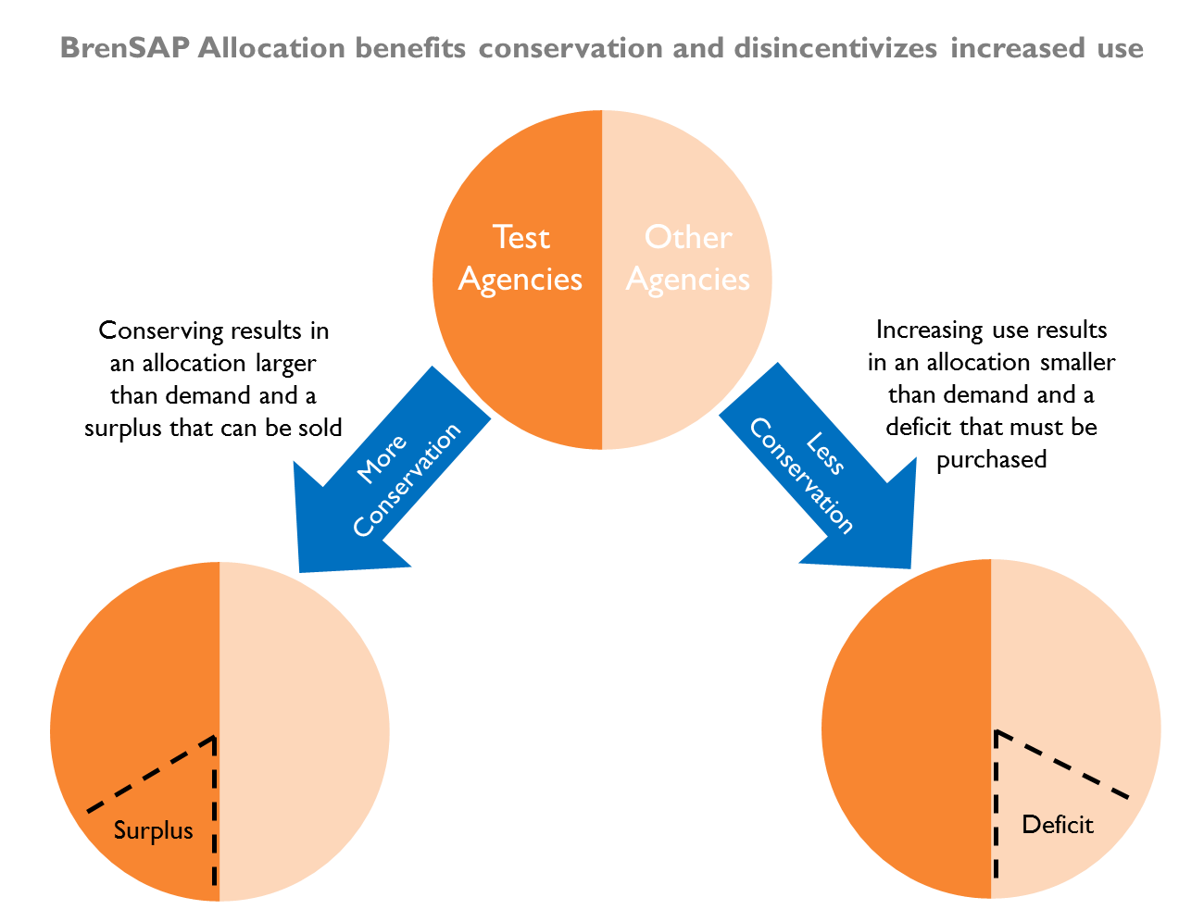

Figure 4‑6. When agencies conserve more, they are rewarded with a surplus that can be sold. When agencies use more water, they no longer receive a larger allocation and will now have a demand that exceeds allocation.

### Analyzing the Potential Market for Allocations

#### Market Conditions

A market for trading use rights to conserved water could take many forms. To help think about the various arrangements that might define and direct trading, we developed a flow path to explore the options that would potentially be available to agencies with either surpluses or deficits (Figure 4‑7). In developing this flow path, we considered the trading platform (brokered vs. non-brokered), trading mechanisms (auctions vs. spot markets vs. options contracts), banking and storage, and market price.

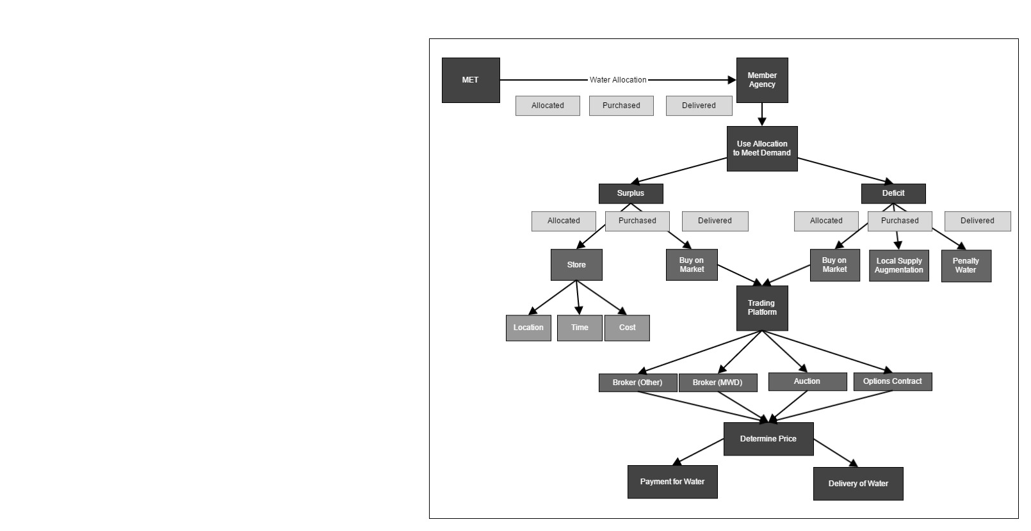

Figure 4‑7. A market considerations flow path that illustrates the options available for the transfer of allocations among member agencies.

The flow path identifies the available options for agencies making decisions in the market. Each decision affects later decisions. For instance, trading an allocated *right to purchase* water has different repercussions to the agencies involved than trading water that has already been purchased by the selling agency. Equally important is whether use rights to allocated water can be banked for future years. The ability to store an unused allocation has implications on forecasting future supplies and managing system capacities and delivery.

All of the options will be important to consider if allocation trading is allowed, and different combinations of options selected can yield different market results. However, for the purposes of our market analysis, the focus was not on determining the best combination of options, but rather to demonstrate what possible benefits might arise from a market.

# Discussion

## Water conservation under the status quo (WSAP)

Our analysis allowed us to quantitatively examine the question of why agencies should conserve water given the current system of water allocation in Southern California. We found that under Met’s existing drought allocation strategy there is not a strong incentive to conserve water because that water is deducted from an agency’s allocation. Agencies who proactively reduce their demand through conservation receive little benefit or security in the event of a drought.

We identified two specific issues in the WSAP that reduce the incentive to conserve:

1. Under the WSAP, water that is conserved since the baseline period is deducted from the allocation. While the WSAP does include a ‘conservation credit’, the credit represents only a small portion of an agency’s conservation reductions.

2. A member agency’s allocation is largely based on a rolling historical average of the most recent years such that the more it uses, the more it is apportioned.

Our exploration of conservation scenarios illustrates that agencies are better off *increasing* their water demand in advance of a drought in order to secure a larger share of supply during a shortage, rather than conserving water to prepare for when supplies are limited. Ironically, this behavior can actually increase the probability that the system will go into shortage and may also the increase the shortage level.

The WSAP is designed to satisfy as much of an agency’s demand for water as it can, regardless of whether the agency’s per capita usage is high or low. In this regard, the WSAP avoids large reductions to an agency’s allocation that might be politically controversial, but in aiming for political expediency, it provides perverse incentives for conservation.

Another element that the WSAP does not provide for is a well-defined and secure use right to purchase water. The WSAP is conceptually an improvement over Preferential Rights in that it better reflects all agencies’ demands and provides flexibility to adapt to an agency’s changes over time. Unlike Preferential Rights, the WSAP allocation does not define a pre-determined quantity that can be purchased. Rather, the WSAP is a form of price control, determining the amount of water an agency may purchase at a given price (under shortage) as a function of their demand. The distinction between Preferential Rights or any other guaranteed right-to-water system is significant when it comes to conservation. If an agency had a predictable and guaranteed allocation, then conservation could provide value by creating a surplus that could then become an asset.

## Water conservation under the BrenSAP

From the perspective of conservation, the BrenSAP allocation system appears to provide a number of advantages over the current WSAP used by Met. The BrenSAP encourages conservation, not just in times of drought, but during all supply conditions. As more agencies proactively manage their demand, there is greater potential for Met to avoid instituting a shortage allocation plan, or if they do, reduce the severity of the required reductions.

The BrenSAP is able to do this because it establishes a static benchmark from which to compare water use over time. The benchmark represents the per capita water use by which an agency is measured, and allocates a share of Met’s total supply accordingly. This provides flexibility to allow for future population growth, and also provides a guide to compare an agency’s use with their allocation. If an agency maintains their per capita water use, even as population increases, no significant effect occurs. If an agency’s per capita water use increases, they will be need to reduce demand or find additional water from a source other than Met. If an agency is proactive and reduces their per capita water use, they are rewarded with a surplus. In doing so, the agency creates opportunity that did not exist under the WSAP: opportunity to better evaluate water use and, if desired, to manage water use to claim the benefits from conservation.

Agencies receive enhanced benefits from conservation when they can trade their surplus water to other agencies. In a market, the surplus water is redistributed through the market process to those agencies who value it most. Agencies who can afford to conserve will do so receive an additional incentive from doing so, and those agencies that demand more than their allocation are able to get more water by purchasing it on the market.

## Benefits of establishing a market for conserved water

For an allocation to incentivize conservation it must provide use rights that are clearly defined, predictable, and secure. Met’s current system provides agencies with an allocation of water as a function of their recent use, which is inherently insecure. As agencies conserve, that quantity decreases and the incentive for conservation is lost.

One solution is to ensure a use right to a share of Met’s supply. If an agency knows how much water it can purchase at a particular rate, it may choose to reduce its water enough to generate a surplus. The allocation then becomes an asset that agencies can incorporate into management decisions. With that asset come options: an agency could potentially use their full allocation, trade a portion for profit, or even store some of it as insurance for future shortages.

If Met were to adopt an allocation system that grants a secure use right, it follows that a market could be established to enable trade. The Met service area represents an ideal platform for such a market because its member agencies share a robust and interconnected water infrastructure. Most trades are therefore reduced to transfers of paper water rights in which conveyance is not a concern, keeping transaction costs low. Met also has the information necessary to effectively track transfers and ensure deliveries, and the authority and resources to administer such a program.

### Potential Economic Gains From Trading Conserved Water

Providing agencies a claim to their conserved water can provide conservation incentives beyond just the trading among surplus and deficit agencies that result from the allocation. A use right to conserved water creates the opportunity for the agencies to engage with each other to conserve water and meet water demands at a lower cost than would be otherwise possible.

The true cost for an agency to conserve water includes the physical cost of implementing a conservation measure, but also includes the forgone value that could have been derived had water not been conserved at all. Because of this, the cost of conservation across Met member agencies differs. An agency’s decision to engage in conservation will depend not only on what conservation opportunities are available, but also how an agency’s customers value each unit of water.

Under the BrenSAP, the ability for agencies to keep the surplus generated by conservation and trade that portion of their allocation to other agencies allows agencies with high conservation costs to pay agencies with low conservation costs to conserve in exchange for the surplus water. This kind of transaction benefits the high conservation cost agencies because they have the option to meet their water demands or conserve water at a price lower than if they had to pursue conservation on their own, and the transaction benefits the low conservation cost agencies because they can receive payment that exceeds their cost of conservation.

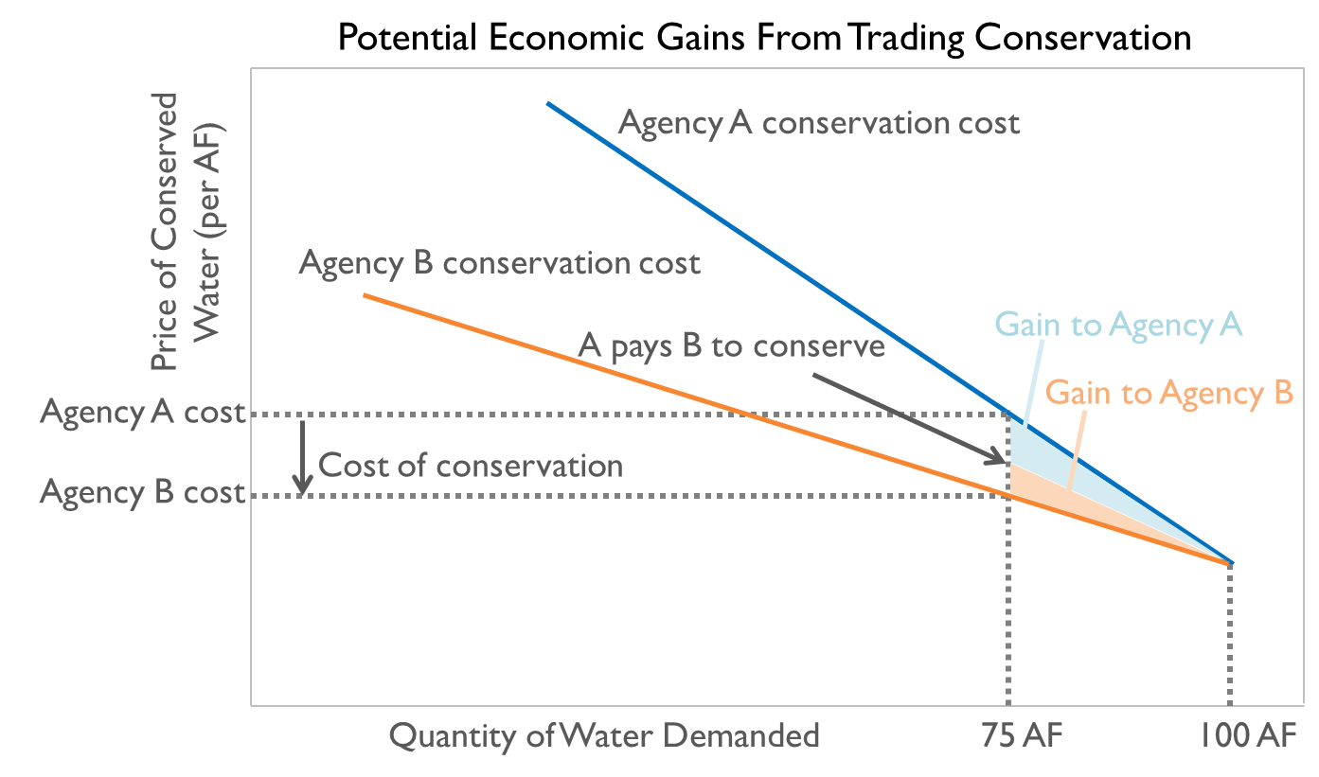

Figure 5‑1. Conservation costs for two agencies can be modeled as demand curves that reflect the value of water to each agency. As agencies conserve, moving from right to left on this diagram, the marginal cost of conservation increases because the value of the next unit of water increases. In this stylized example, Agencies A and B both use 100 AF/year, but Agency A has a more inelastic demand curve, and hence higher average conservation costs (perhaps due to demand hardening or a consumer preference for green lawns). In a market, Agency A can pay Agency B to conserve 25 AF of water, at a total cost that is less than its own costs to conserve. Agency A gains use rights to the surplus water that is created. Meanwhile, Agency B gets paid more than its own costs of conservation, so it makes a profit.

Figure 5‑1 represent two agencies with a demand for 100 AF of water. The downward sloping blue lines represent each agency’s cost of conservation, and the price of conserved water on the y-axis includes the cost to conserve and the value of that water to its users. With each AF of water conserved, the cost of conservation becomes increasingly higher. The least costly acre foot for an agency to conserve will be the first acre foot they conserve. With each subsequent acre-foot an agency conserves, the more costly conservation is to that agency. Another way to interpret Figure 5‑1 is that if the demand for water is 100 AF, the value of water increases for every unit that is no longer available to meet demand. This is why the conservation cost curve goes up on the chart as the quantity of water demanded decreases to the left.

In this example, Agency A represents an agency with a high cost of conservation, and Agency B is an agency with a lower cost of conservation. If Agency A was required to conserve 25%, such as under the Governor’s 2015 mandatory water reductions, then without the ability to keep conserved water and trade surplus, as proposed under the BrenSAP, Agency A would have to incur its own high costs to achieve that conservation. However, the ability to trade surplus generated through conservation, as permitted with the BrenSAP, allows Agency A to achieve conservation more efficiently. Agency A could pay Agency B, an agency with lower costs of conservation, to implement conservation measures in the Agency B service area. In return for the payment, Agency A would receive the credit for conservation if seeking to meet the Governor’s mandate, or Agency A could receive Agency B’s surplus if it was seeking additional supply.

This type of mutually beneficial transaction could be pursued by all Met agencies such that Met system-wide conservation could be achieved in the most cost efficient manner possible. As a result, agencies acting in their own best interests are also simultaneously promoting conservation and efficiency improvements across the system as a whole.

## Challenges of Allocating Water

The BrenSAP allocation system illustrates some of the benefits that could be found in applying a new method for distributing and managing water. However, our process is only a rough sketch for what might be done through allocating water to promote conservation. While we present a conceptual example of how two agencies may interact, a more predictive look at the full range of interaction between all Met member agencies is subject to many complex and highly dynamic variables. The ability of an agency to secure the benefits of their conservation will depend on that agency’s costs of conservation, the other Met member agencies’ costs of conservation, the prices of water established by Met, the design of the allocation system, and the constraints imposed by the market platform structure and conditions of trade.

The process we outline in this document is not intended to be “the” solution, rather our goal has been simply to explore the potential for change to occur that might better address the increasing demands for water on an increasingly limited supply. Our hope through this exercise is to stimulate dialogue and creative thinking in how to respond to that issue. Through our research, we identified key factors with the current system that appear to limit conservation, reviewed alternatives, and present a logical and reasonable approach to thinking about a specific question, which is how to design an allocation system that promotes conservation. Ultimately, the details of a change to the system will be the result of much more in-depth analysis, and negotiation among the parties involved and affected.

Our system assigns shares to users of a scarce resource. In doing so, the allocations effectively produce winners and losers in terms of how those shares meet the demands on each agency. Therefore the assignment shares, and the opportunities provided to agencies through allocation, would inherently generate debate, especially for those agencies whose allocation is reduced from previous amounts. Adoption of a new system is therefore not only a logistical problem but a political one as well. This is particularly true under Met governance where member agencies themselves have representation and influence in the management of Met water supplies. In developing our approach, we also took political considerations into account and attempted to design a system that maintains a balance in the water demands between surplus and deficit agencies, as well as preserves the revenue to Met. Despite this, as previously stated, we recognize that the complexity of issues and the political negotiation that must occur is much more intricate than our simplified approach may suggest. However, as difficult as the political negotiations might be, it is evident that new and better mechanisms to motivate conservation and efficiently distribute water supplies are needed. Hopefully our research highlights the considerations that must be contemplated and provides an outline toward developing a workable solution.

# Conclusions

We have seen that the current system of drought allocation in Southern California does not provide strong incentives for agencies to conserve in the years leading up to and during a drought. An approach like the one we present would reduce demand on increasingly scarce water resources, reduce the need to develop new supply sources, and make urban populations more resilient to environmental shocks, such as drought. Providing agencies with a guaranteed use rights-based allocation also provides flexibility for future planning decisions. In a system like the BrenSAP, agencies must internalize the costs and benefits of their water use decisions. If they have a surplus, they could sell their conserved water to other agencies, or they could potentially reserve some surplus to provide for other management decisions such as new local development, storage for future years, or designate some portion for environmental benefits.

Both of Met’s water sources are vulnerable to shortages brought about by increasingly frequent droughts. When the Colorado River and SWP cannot supply enough water to meet demand, Met and its member agencies must seek costly additional supplies. For example, agencies may increase groundwater withdrawals, plan new desalination plants, or purchase water from irrigation districts. In the short term, Met can pay farmers north of the Delta to fallow their fields, often at a steep price. In the past, Met has been able to offer a high enough price to entice some farmers to sell or lease their water. This may no longer be true in California, as premium crops become more prevalent throughout the Sacramento-San Joaquin Valley. If this trend continues, Southern California may not be able to rely on Central Valley agriculture for supplemental water as it has in the past.

A market system would also increase the reliability and resilience of the Met system. By reducing system-wide demand, such a system could decrease the frequency of shortages and reduce the duration and severity of shortages when they do occur. This is important because droughts in California are predicted to become more frequent and more severe due to climate change.

Finally, reducing Southern California’s need for imported water may have environmental benefits. By providing agencies the ability to generate and sell surpluses, a market system provides opportunities for that water to be purchased or designated for environmental uses. Having more water in surface storage could also provide enhanced riparian habitat. Avoiding the construction of new infrastructure such as desalination plants and aqueducts reduces further degradation of our already sensitive ecosystems.

The challenge for Southern California over the next century is to live within its current water supplies even as its population and economy grow. We now find ourselves in a new era of scarcity when water reliability will have to come from better managing our demand. When designing systems to allocate our scarce water supplies, we therefore have to consider the incentives for conservation as a key component. Markets will be one increasingly important tool for achieving these goals.

# Acknowledgements

We wish to thank Kevin Wattier and Matt Lyons of the Long Beach Water Department for proposing this project and providing invaluable feedback along the way. Brianna Pagan at the Long Beach Water Department helped us procure needed data on numerous occasions. We thank the Metropolitan Water District of Southern California for providing us with the data that formed the basis of this project.

We are also grateful to Dr. Robert Wilkinson at the Bren School for his insights into Southern California water politics. Dr. Allison Horst was invaluable in helping us to frame our project. Finally, we thank our advisor, Dr. Gary Libecap, for his tremendous support, valuable input, and enthusiasm for our project.

# References

*20x2020 Water Conservation Plan*. California Department of Water Resources, February 2010. http://www.swrcb.ca.gov/water_issues/hot_topics/20x2020/docs/20x2020plan.pdf.

“California Officials Admit They Have Incomplete Water Usage Data.” *Los Angeles Times*. Accessed February 16, 2015. http://www.latimes.com/local/la-me-water-use-war-20140727-story.html.

“CA Water Code Subsection 350 (Water Shortage Emergency).” Accessed April 10, 2014. http://www.leginfo.ca.gov/cgi-bin/displaycode?section=wat&group=00001-01000&file=350-359.

Erie, Steven P, and Harold David Brackman. *Beyond Chinatown: The Metropolitan Water District, Growth, and the Environment in Southern California*. Stanford: Stanford University Press, 2006.

“Governor Brown Declares Drought State of Emergency.” *Office of Governor Edmund G. Brown Jr.*, January 17, 2014. http://gov.ca.gov/news.php?id=18379.

Hardin, Garrett. “The Tragedy of the Commons.” *Science*, New Series, 162, no. 3859 (December 13, 1968): 1243–48.

Lloyd, Jonathan. “California Meets Water-Use Goal for First Time.” *NBC News*, February 3, 2015. http://www.nbcbayarea.com/news/local/California-Water-Use-Conservation-Drought-290642631.html.

*Managing an Uncertain Future: Climate Change Adaptation Strategies for California’s Water*. California Department of Water Resources, October 2008. http://www.water.ca.gov/climatechange/docs/ClimateChangeWhitePaper.pdf.

*MWD Annual Report for the Fiscal Year 2013-2014*. Metropolitan Water District of Southern California. Accessed January 20, 2015. http://www.mwdh2o.com/mwdh2o/pages/finance/FY13-14-CAFR.pdf.

*MWD Water Surplus and Drought Management Plan*. Metropolitan Water District of Southern California, 1999. http://www.mwdh2o.com/mwdh2o/pages/yourwater/WSDM_Report1150.pdf.

*News Release: Gearing up for More Drought, Metropolitan Water Board Revises Supply Allocation Plan, Also Adds $40 Million to Rebate Program*. Metropolitan Water District of Southern California, December 9, 2014. http://www.mwdh2o.com/mwdh2o/pages/blog/8-21-14.html.

O’Connor, Dennis. *The Governance of the Metropolitan Water District of Southern California: An Overview of the Issues*. California Research Bureau, August 1998. https://www.library.ca.gov/crb/98/13/98013.pdf.

“Persistent Drought Conditions Could Compel Metropolitan to Limit Imported Water Supplies for Region This Summer.” *Metropolitan Water District of Southern California Press Release*, February 9, 2015. http://www.mwdh2o.com/mwdh2o/pages/news/press_releases/2015-02/Allocation_scenarios_introduced.pdf.

“San Diego County Water Authority Petitions State Supreme Court on Preferential Rights.” San Diego County Water Authority. Accessed April 10, 2014. http://www.sdcwa.org/san-diego-county-water-authority-petitions-state-supreme-court-preferential-rights.

Schoch, Deborah. “Drought Plan Opens Deep Rifts over Fairness.” *Los Angeles Times*, January 20, 2008. http://articles.latimes.com/2008/jan/20/local/me-water20.

“State Water Board Approves Emergency Regulation to Ensure Agencies and State Residents Increase Water Conservation.” *State Water Resources Control Board*, July 15, 2014. http://www.waterboards.ca.gov/press_room/press_releases/2014/pr071514.pdf.

*The Metropolitan Water District Act of 1969*, 1969. http://www.mwdh2o.com/rsap/Act.pdf.

“United States Drought Monitor.” *National Drought Mitigation Center*, January 15, 2015. http://droughtmonitor.unl.edu/.

Veeh, Matthew. “Long Beach July Water Use Lowest Since 1958.” *Long Beach Water Department*, August 1, 2014. http://lbwater.org/Long-Beach-July-Water-Use-Lowest-Since-1958.

Walton, Brett. “California Drought: A Dry January Closes and Dread Mounts.” *Circle of Blue WaterNews*, January 29, 2015. http://www.circleofblue.org/waternews/2015/world/california-drought-a-dry-january-closes-dread-mounts/.

Zetland, David. “The End of Abundance: How Water Bureaucrats Created and Destroyed the Southern California Oasis.” *Water Alternatives* 2, no. 3 (2009): 350–69.

# Appendix A: Charts and Tables

Figure 9‑1 below shows the 2015 Water Supply Allocation Plan, the process by which Met calculates member agency allocations during a regional shortage. A detailed description of most elements can be found in Section 2.4, pages 2–21 of Met’s 2010 Regional Urban Water Management Plan.

The flow lines represent which elements are used as inputs to calculate subsequent elements, and the “+”, “–”, or “×” represent how the element is applied to the value in the following box: added, subtracted, or multiplied.

The four rectangular boxes at the right of the diagram are the key components used to calculate an agency’s municipal and industrial (M&I) allocation. The wholesale minimum allocation can be considered as the “base” allocation, and the other three boxes are adjustments to the base allocation. The M&I allocation was the only allocation evaluated for our project, but the WSAP also separately calculates an allocation for replenishment and seawater barrier allocations.

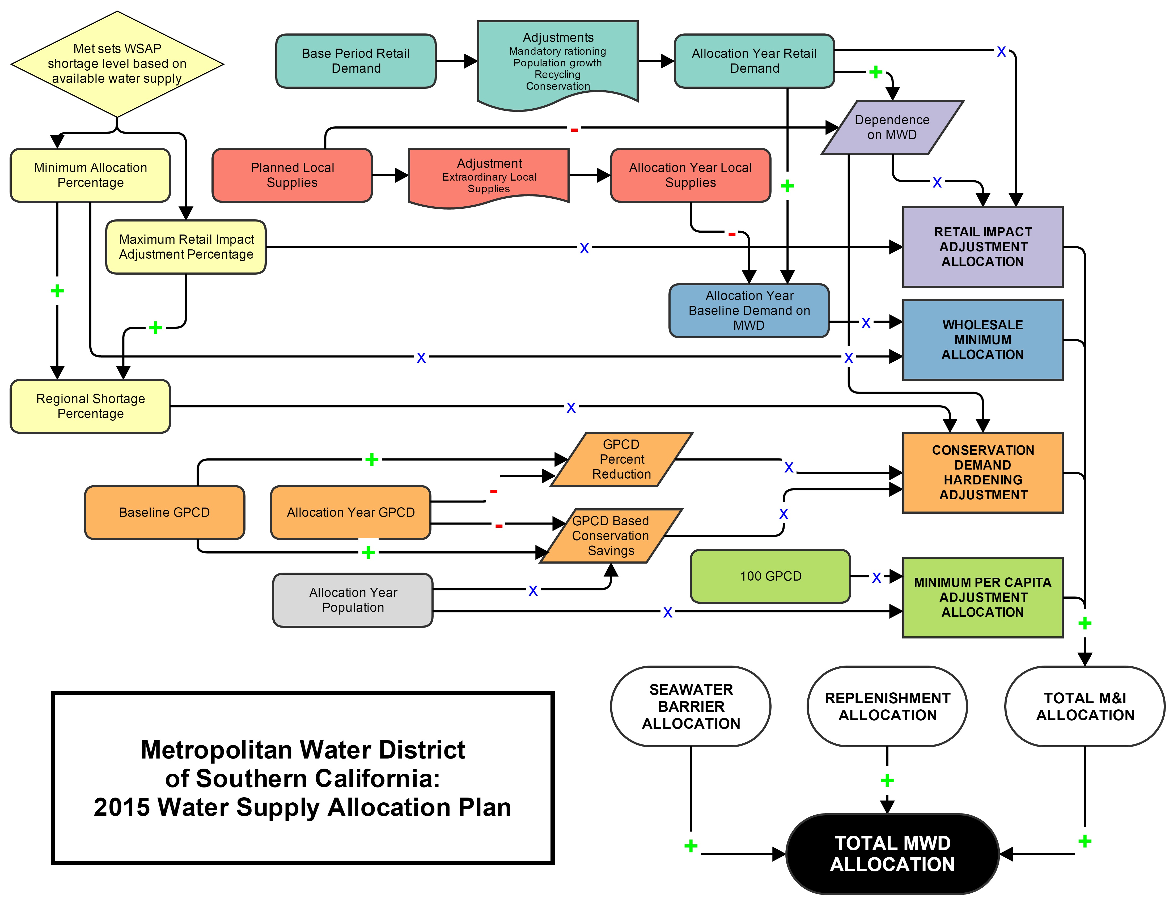

Figure 9‑1. Met’s 2015 Supply Allocation Plan.

Table 9‑1. Estimated allocations to each of the 26 Met member agencies under the Met 2015 WSAP and the BrenSAP developed for this project. The assumptions (supply, demand, population, conservation, etc.) used to calculate these results can be found in the attached Excel document in “Document A-1.”



Document A-1. Assumptions used to calculate WSAP and BrenSAP allocations



# Appendix B: Alternative Allocation Systems

When analyzing alternative allocation systems, in order to meaningfully compare allocations to each other the total supply of water must be the same for each allocation system. We held the total supply of water available under each system to be the same as the total supply allocated by the 2015 WSAP under two supply scenarios: No shortage, and a 10% reduction (Stage 2 Shortage). As of February 2015, Met anticipates a Stage 2 shortage for the 2015-16 water year.[26]

## Preferential Rights

Preferential rights are determined by calculating each agency's cumulative historical payments, in nominal unindexed dollars, for four types of contributions:

1. Property taxes, excluding the agency annexation fee (1930 – present)
2. Readiness-to-Serve charge (1993 – present)
3. Capacity charge (2003 – present)
4. Contributions in aid of construction (1930 – present).

The result is expressed as a percentage of the total payments for all agencies. Importantly, payments related to the actual purchase of water are excluded from the calculation of preferential rights.[27] Note also that the use of unindexed payments in nominal dollars gives greater weight to payments made in the past than if inflation-adjusted payments in real dollars were used; this places agencies that joined Met in later years at a disadvantage.

We obtained published preferential rights from Met for year 2013, the most recent available. We then adjusted them by the annual rate of growth from 2010—13 to give estimated 2015 values. To convert the rights into water allocations that can be compared with the status quo WSAP, we multiplied each agency’s rights by the total supply of water calculated by the 2015 WSAP under both a No Shortage and a Shortage Level 2 scenario.

### Modified Preferential Rights

Preferential rights as an allocation system has been criticized by some agencies because it does not account for contributions related to the volumetric purchases of water. To address some of the equity concerns over preferential rights, we explored an allocation system called Modified Preferential Rights (MPR), which is calculated similarly to existing preferential rights (PR) but differs in two regards:

1. MPR incorporate cumulative historical water purchases from Met over the lifetime of the agency.
2. As with our other allocation systems, MPR do not provide an ownership right to an share of water, but rather a right to purchase a share of water at a fixed annual rate.

To calculate the Modified Preferential Rights for each agency, we obtained data on annual nominal payments made to Met from 1930 to 2010, broken down by agency and type of payment.[28] The 2010 rights for an arbitrary agency *j* were calculated according to the formula:

$${MPR}_{j, 2010} \left(\%\right)= \frac{\sum_{1930}^{2010}{{PropTax}_{j}}+\sum_{1993}^{2010}{{RTS}_{j}}+\sum_{2003}^{2010}{{CC}_{j}}+\sum_{1930}^{2010}{{CAC}_{j}}+\sum_{1930}^{2010}{{Water}_{j}}}{\sum_{1930}^{2010}{Total Payments from all agencies}}×100$$

where:

* *PropTax* is the annual property tax revenue (excluding agency annexation fees)
* *RTS* are annual payments from the Readiness-to-Serve charge (instituted in 1993)
* *CC* are annual payments from the Capacity Charge (instituted in 2003)
* *CAC* are annual payments for Contributions in Aid of Construction
* *Water* is payments for the volumetric purchase of water (including treated, untreated, exchange, agricultural, and replenishment water)

Because we were unable to procure payment data more recent than 2010, we estimated the 2015 MPR for each agency by multiplying its 2010 MPR by the mean annual percent change in published preferential rights (PR) from 2010 to 2014 for that agency:

$${MPR}_{j, 2015}≈{MPR}_{j, 2010} ×\frac{{PR}_{j, 2014}-{PR}_{j, 2010}}{{PR}_{j, 2010}}×\frac{5}{4}$$

Since the annual rate of change of each agency’s rights is quite stable (Figure 2‑3), we assumed that the resulting estimates are very close to the actual values.

After calculating the rights percentages for each agency, we compared the amount of water allocated under both PR and MPR to the quantity each agency would receive under the 2015 WSAP during both a No Shortage and a Shortage Level 2 scenario.

Table 10‑1 shows how our Modified Preferential Rights compare to the published preferential rights. As expected, San Diego is the major benefactor of including water revenues in the calculation; their share increases from 18.5% to 24.8% of total supply, in line with their actual share of water purchases in the 2000s. Calleguas, Three Valleys, Eastern, West Basin, and MWDOC also receive larger shares. Los Angeles loses the most shares, from 20.0% down to 13.2%. Central Basin and Upper San Gabriel also lose shares. The far right column of Table 10‑1 shows that even though the change to some agencies’ rights is small in absolute terms, it can represent a gain or loss of a large portion of their existing rights. This is particularly true of the smallest agencies.

Table 10‑1 shows how both existing and modified preferential rights translate into allocations of water for each agency. To understand the practical impacts of this allocation system, we assume that the total supply of water to be allocated is the same as the total amount purchased by all agencies during the 2013-14 water year (2,138,075 AF; this includes treated, untreated, and exchange water), which is our best estimate of each agency’s demand for imported water during 2015-16.[29] We then calculate the difference between the preferential rights allocation and the quantity of water actually purchased from Met during 2013-14. The red and green bars show the extent to which each agency would have a surplus or deficit allocation.

Table 10‑1. Estimated existing (PR) and modified (MPR) preferential rights for the year 2015, expressed as shares of total annual Met supply. Under MPR, San Diego gains shares at the expense of Los Angeles. Existing rights are based on the last published year available (2013). Modified rights are based on historical payment data from 1930 through 2010. Data from MWD.



Table 10‑2. Hypothetical drought allocations to member agencies for the year 2015, in acre-feet, based on both existing and modified preferential rights. Red and green bars show the difference between the allocation and the actual quantity of water purchased from Met in the most recent year (2013-14). Agencies with green bars hold a surplus of water that could be sold in a market to those agencies with red bars. Agencies are ordered by greatest surplus to greatest deficit. Data from MWD.



Preferential rights as an alternative to the WSAP has a legal foundation, but that legal foundation was set decades ago and does not account for the numerous changes in the number and composition of Met member agencies. Preferential Rights was not structured to provide flexibility for new entrants into the Met system over time, nor could it predict the demands that would need to be met by a southern California population nearing 19 million residents. Preferential Rights does provide a guarantee to purchase a quantity of water which could then allow for the benefits of conservation to be incorporated, however due to the manner in which they are calculated, invoking Preferential Rights does little to address true agency demands, rather it simply rewards the founding Met member agencies based on their contribution to Met infrastructure, their longevity as a member, and the relative wealth of the community. Our version of a ‘Modified Preferential Rights’ allocation system attempts to address some of these inequities by incorporating an agency’s contribution to Met capital through water purchases. In this way, it better balances the discrepancy in allocations between founding member agencies and subsequent members, but it still retains some of the inequities based on differences in property taxes.

The fact that revenues from the sale of water are explicitly excluded from the preferential rights calculation has been criticized by SDCWA. San Diego is Met’s largest customer by volume of water purchased, thanks to the large volume of untreated agricultural water that it purchases. San Diego argues that payments for water should be included because Met nowadays receives most of its operating expenses and capital costs from the sale of water, not property taxes.[30]

The exclusion of water revenues makes preferential rights essentially blind to an agency’s current water use and level of dependence on Met. For example, San Diego accounted for 24% of Met’s total water revenues in 2005,[31] and has purchased 26% of Met’s water over SDCWA’s lifetime, yet they have preferential rights to only 18% of Met supply.[32] SDCWA has argued that if preferential rights were ever invoked and San Diego were cut back to this amount, the agency would face a severe shortage, particularly because the region has little local supply and is thus dependent on Met for ~80% of its demand. Citing this concern, SDCWA sued Met in 1991 to have the formula for preferential rights changed;[33] they lost the suit in 2004 but filed additional lawsuits in 2011 which are still pending.[34] The fear of being cut off during a drought also prompted SDCWA to pursue a historic water transfer agreement with the Imperial Irrigation District. The additional water supply from this agreement allowed San Diego to reduce its water purchases down to ~18% of Met’s supply in 2013—14, in line with its preferential rights.

We suspect that few water managers, even within LADWP, would argue that preferential rights as they now exist should be used to allocate water in a drought. Yet because preferential rights have a basis in statutory law, they linger in the background of many negotiations – a threatening ‘nuclear option’ that could be invoked as a last resort. During a drought, any member agency could legally invoke its preferential right by demanding to purchase its assigned share of water from Met. Preferential rights therefore act as a backstop measure that is likely to materialize only in a severe shortage of the kind we have not yet seen in Southern California.

Because of the political infeasibility of making large cuts to the supply of agencies like SDCWA, preferential rights have never been invoked (and may in fact be illegal under California Water Code section 350, which sets limits on how agencies may allocate water during official water shortages).[35] Instead, Met has drafted alternate allocation plans based on historical usage, which provide a less drastic level of cutbacks for all agencies.

In this project, we have taken preferential rights as the starting point for one of the three rights allocations we will consider. In doing so, we suggest that historical investment in infrastructure is one possible way to allocate rights, but we also recognize that there are serious equity concerns with this approach, such as those raised by San Diego.

## Gallons Per Capita Per Day (GPCD) Benchmark

GPCD is a metric that is useful to compare water use between groups. GPCD has been suggested by some as a basis for uniform allocations, which has the appeal of holding all users to the same benchmark. We create a simplified version of a gpcd-based allocation by applying a single gpcd benchmark across all agencies. Under this approach, the gpcd benchmark sets the amount of water each member agency has an initial use right to purchase from Met.

The total amount of water that is allocated to the entire Met system is determined by a gpcd benchmark that is applied uniformly to all agencies. For this analysis, the gpcd target was set at 170.58 when Met is not in shortage, and at 163.45 when Met is in a level two shortage. Analyzing the distribution of water at this level of supply allows us to meaningfully compare the allocations of water across all our allocation methods.

Data on 2015 population estimates, 2015 local supply quantities, and water purchased from Met in 2015 were gathered from the 2015 WSAP. Population data for each agency were used to estimate the total population of the Met service area. Local supply data for each agency were used to estimate the total local supply of the Met service area. The amount of water each agency requests to purchase from Met in 2015 was aggregated to determine the total Met demand of the service area. These datasets were used to determine the gpcd benchmark for non-shortage and level two shortage years.

#### Setting the gpcd

The non-shortage gpcd was determined by adding the 2015 total local supply, and the 2015 total Met demand. This total was then divided by the total population of the Met service area. Lastly, the result was converted from acre feet per year to gallons per day:

$$Non-shortage year GPCD= \frac{Met Demand \left(AF\right)+Local Supply \left(AF\right)}{Total Population }×\frac{325851 gallons/acft}{365 days}$$

$$Non-shortage year GPCD=\frac{1,764,548 AF+1,791,189 AF}{18,609,536}×\frac{325851 gal/acft}{365 days}$$

$$Non-shortage year GPCD=170.58$$

The level two shortage gpcd was determined by adding the 2015 total local supply, and the total Met supply under a level two shortage identified in the WSAP. This total was then divided by the total population of the Met service area. Lastly, the result was converted from acre feet per year to gallons per day:

$$Level 2 shortage GPCD= \frac{Met Supply \left(AF\right)+Local Supply \left(AF\right)}{Total Population }×\frac{325851 gallons/acft}{365 days}$$

$$Non-shortage year GPCD=\frac{1,616,087 AF+1,791,189 AF}{18,609,536}×\frac{325851 gal/acft}{365 days}$$

$$Non-shortage year GPCD=163.45$$

Using this methodology to set the gpcd levels for shortage years ensures the total allocation to all member agencies does not exceed Met’s supply.

#### Determining the Allocation

Once the gpcd in shortage and non-shortage years is determined it is used to determine the amount of water allocated to each member agency. The gpcd (Non-shortage gpcd 170.58, or Shortage level 2 gpcd 163.45) was multiplied by the 2015 population for each agency. Long Beach Water Department under non-shortage conditions is provided as an example to illustrate the allocation method:

$$Initial Allocation=\left(2015 Population × Non\text{-}shortage GPCD\right)-2015 Local Supply$$

$$LBWD Initial Allocation=\left(481,579 people ×170.58 GPCD\right)=78,714,077 {Gallons}/{Day}$$

Allocations were then converted to acre feet:

$$83,385,939 {Gallons}/{Day} →88,171 {AF}/{Year}$$

Local supplies were then subtracted to determine an agency’s allocation from Met:

$$88,171 {AF}/{Year}-29,085 AF=59,086 AF$$

Each agency’s gpcd allocation is compared to the amount of water they have requested to purchase in 2015 according to 2015 WSAP. Comparison of the gpcd allocation and purchased water indicates whether the allocation method will result in a surplus or a deficit for the agency. If the amount of water allocated to the agency is greater than the amount of water they were projected to purchase in 2015 the agency is considered to have a surplus. If the amount of water the agency is allocated based on the gpcd method is less than the amount they were projected to purchase in 2015 the agency is considered to have a deficit.

$$GPCD Alloction-2015 MWD Purchase=Surplus or Deficit$$

$$59,086 AF-30,975 AF=28,111 AF \left(Surplus\right)$$

In our gpcd allocation, the total amount of water that is allocated to the Met system is determined by a gpcd benchmark that is applied uniformly to all agencies. If we set the benchmark to **171** gpcd, we obtain a total allocation equivalent to that of the 2015 WSAP under a no shortage scenario (1.764 million AF), allowing us to compare the distribution of water under both systems (Table 10‑3, left column).

In our simple formulation, the amount of water allocated to each agency is determined by multiplying the benchmark by the agency’s population. Agencies with gpcd’s above the benchmark have deficits, while those with gpcd’s below the benchmark are left with surpluses.

With the exception of the San Diego County Water Authority, the agencies with the largest surpluses tend to be older, built-out cities with high-density urban land use. These cities have a large proportion of multifamily housing, smaller lawns, and little agriculture. The agencies with deficits tend to be the fast-growing outlying areas of Riverside, San Bernardino and Ventura counties. These agencies have low-density, suburban land use, large lawns, and significant agriculture. They also tend to be located in hotter, dryer inland areas.

In a stage 2 shortage, as may occur this year, total supply is reduced 10% to 1.616 million AF. We reduce the gpcd benchmark to **163** to model this scenario. During a shortage, not all system demand can be met, and more agencies will have deficits (Table 10‑3, right column). Consequently, agencies will be motivated to conserve.

Table 10‑3. Bars showing the difference between the amount of water allocated under a uniform gpcd system (in AF) and the amount each agency would receive under the 2015 WSAP. Two scenarios are shown: normal supply conditions (left) and Level 2 Shortage conditions (right). Older agencies representing urbanized, high-density areas tend to receive surpluses under this system, while younger agencies representing low-density exurbs have deficits.



Figure 10‑1 illustrates the differences between agency demand and allocation under the gpcd scenario for a low water use agency (Long Beach) and a water use agency (Calleguas). Long Beach’s allocation would exceed their demand, creating a surplus; Calleguas’ allocation would not be enough to meet their demand, creating a deficit. In a market scenario, Calleguas could fulfill their deficit by purchasing from Long Beach.

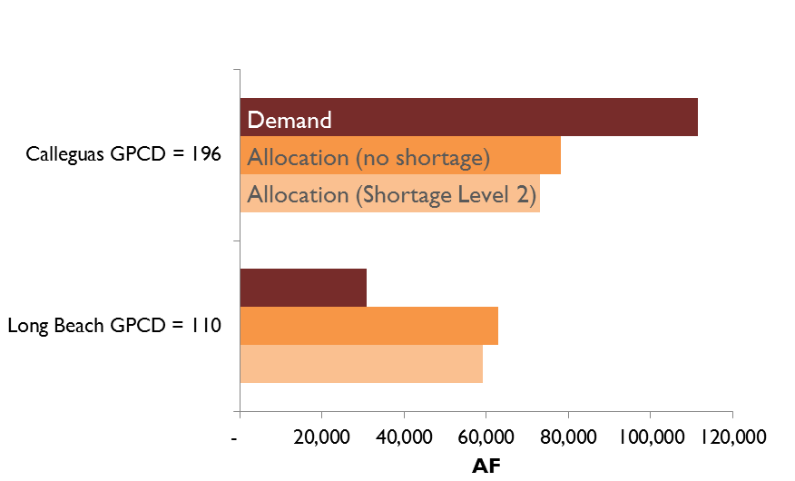

Figure 10‑1. Comparison between the water demanded and allocation provided for a low gpcd agency (Long Beach) and a high gpcd allocation (Calleguas) when the uniform gpcd benchmark is set at 171 (no shortage) and 163 (shortage level 2).

#### Shortcomings of this method

We have presented a simplified gpcd allocation that uses a single gpcd benchmark that is uniform across all agencies and all sectors, under the assumption that differences in agency gpcd represent different levels of conservation effort. However, holding all agencies to the same gpcd benchmark fails to account for many heterogeneities that are unrelated to conservation effort:[36]

*Weather:* Agencies in hotter, dryer areas consume more water per capita for landscape irrigation.

*Population density and land use:* Agencies with lower population densities consume more water per capita for landscape irrigation.

*Socioeconomic factors:* Agencies with more affluent populations and larger lot sizes consume more water per capita for landscape irrigation.

*Sector mix:* Agencies with more industrial and agricultural users consume more water per capita.

*Retail water pricing:* Agencies with lower retail prices consume more water per capita. (Although retail pricing might be considered an element of conservation effort, in practice agencies are limited in their ability to raise prices by state laws such as Prop 218).

Allocating water using a uniform benchmark like gpcd establishes an efficiency target for member agencies, eliminating some of the political and social inequities inherent in other forms of allocation. However, a uniformly applied gpcd target provides little flexibility and does not account for heterogeneous water use among different sectors of users. We found that this system would give surpluses to older, more urbanized cities, while exurban outlying areas would have deficits (Table 10‑3).

Due to time and data availability constraints, our gpcd allocation example does not address agency heterogeneities. Yet, we fully recognize the distributional effects that a uniform gpcd benchmark could have, particularly for those that have industry or agriculture that inherently uses more water by necessity. A more politically feasible gpcd-based allocation might include gpcd benchmarks for different sectors (industrial, commercial, agricultural, high/low-density residential) and then adjust an agency’s allocation based on its individual mix of sectors, possibly also including weather and pricing factors. However, such an exercise, if taken too far, could easily lead back to a complicated need-based system of credits and adjustments, much like the WSAP. We believe that a balance should be struck between the simplicity, elegance, and perceived fairness of a single uniform benchmark, and the reality of heterogeneous agencies. Our BrenSAP allocation aims to achieve that balance.

1. “Governor Brown Declares Drought State of Emergency,” Office of Governor Edmund G. Brown Jr., January 17, 2014, http://gov.ca.gov/news.php?id=18379.
2. “California Officials Admit They Have Incomplete Water Usage Data,” *Los Angeles Times*, accessed February 16, 2015, http://www.latimes.com/local/la-me-water-use-war-20140727-story.html.
3. “State Water Board Approves Emergency Regulation to Ensure Agencies and State Residents Increase Water Conservation,” *State Water Resources Control Board*, July 15, 2014, http://www.waterboards.ca.gov/press_room/press_releases/2014/pr071514.pdf.
4. Jonathan Lloyd, “California Meets Water-Use Goal for First Time,” *NBC News*, February 3, 2015, http://www.nbcbayarea.com/news/local/California-Water-Use-Conservation-Drought-290642631.html.
5. “United States Drought Monitor,” National Drought Mitigation Center, January 15, 2015, http://droughtmonitor.unl.edu/.
6. *Managing an Uncertain Future: Climate Change Adaptation Strategies for California’s Water* (California Department of Water Resources, October 2008), http://www.water.ca.gov/climatechange/docs/ClimateChangeWhitePaper.pdf.
7. Dennis O’Connor, *The Governance of the Metropolitan Water District of Southern California: An Overview of the Issues* (California Research Bureau, August 1998), https://www.library.ca.gov/crb/98/13/98013.pdf.
8. MWD Water Surplus and Drought Management Plan (Metropolitan Water District of Southern California, 1999), http://www.mwdh2o.com/mwdh2o/pages/yourwater/WSDM_Report1150.pdf.
9. “Persistent Drought Conditions Could Compel Metropolitan to Limit Imported Water Supplies for Region This Summer.,” Metropolitan Water District of Southern California Press Release, February 9, 2015, http://www.mwdh2o.com/mwdh2o/pages/news/press_releases/2015-02/Allocation_scenarios_introduced.pdf.
10. For an overview of Met history with regard to preferential rights, see David Zetland, “The End of Abundance: How Water Bureaucrats Created and Destroyed the Southern California Oasis,” *Water Alternatives* 2, no. 3 (2009): 350–69. and Steven P Erie and Harold David Brackman, *Beyond Chinatown: The Metropolitan Water District, Growth, and the Environment in Southern California* (Stanford: Stanford University Press, 2006).
11. Deborah Schoch, “Drought Plan Opens Deep Rifts over Fairness,” *Los Angeles Times*, January 20, 2008, http://articles.latimes.com/2008/jan/20/local/me-water20.
12. *News Release: Gearing up for More Drought, Metropolitan Water Board Revises Supply Allocation Plan, Also Adds $40 Million to Rebate Program* (Metropolitan Water District of Southern California, December 9, 2014), http://www.mwdh2o.com/mwdh2o/pages/blog/8-21-14.html.
13. “Persistent Drought Conditions Could Compel Metropolitan to Limit Imported Water Supplies for Region This Summer.”
14. *News Release: Gearing up for More Drought, Metropolitan Water Board Revises Supply Allocation Plan, Also Adds $40 Million to Rebate Program*.
15. Water use data from 1977-2013 provided by Matt Lyons at the Long Beach Water Department.
16. Matthew Veeh, “Long Beach July Water Use Lowest Since 1958,” *Long Beach Water Department*, August 1, 2014, http://lbwater.org/Long-Beach-July-Water-Use-Lowest-Since-1958.
17. Garrett Hardin, “The Tragedy of the Commons,” *Science*, New Series, 162, no. 3859 (December 13, 1968): 1243–48.
18. Even though these numbers may not be completely accurate, for the purposes of our analysis in analyzing the directionality of hypothetical changes, the absolute accuracy of the initial numbers was not necessary. All we needed was an approximate starting point from which to begin performing hypothetical scenario testing.
19. Brett Walton, “California Drought: A Dry January Closes and Dread Mounts,” *Circle of Blue WaterNews*, January 29, 2015, http://www.circleofblue.org/waternews/2015/world/california-drought-a-dry-january-closes-dread-mounts/.
20. MWD average gpcd is calculated using the aggregated demand and population numbers prepopulated in the WSAP spreadsheet for all member agencies.
21. *20x2020 Water Conservation Plan* (California Department of Water Resources, February 2010), http://www.swrcb.ca.gov/water_issues/hot_topics/20x2020/docs/20x2020plan.pdf.
22. Board Letter 8-8. *The Metropolitan Water District of Southern California Water Planning and Stewardship Committee Board Meeting.* August 17, 2010.
23. For the 2015 WSAP, Met allows agencies some flexibility in defining its historical demand as long as it is based on a 10-year average ending sometime between 2004 and 2010.
24. There is an accommodation in the WSAP Conservation Demand Hardening formula to account for percentage reduction, but this percent reduction does not take into consideration the gpcd starting point, so agencies reducing from a high gpcd receive the same credit for the same percentage conservation as an agency reducing from a low gpcd.
25. Some conservation costs are partially subsidized by Met through the Water Stewardship Rate, which is a charge paid by member agencies on each unit of water they purchase from Met.
26. Walton, “California Drought.”
27. The Metropolitan Water District Act of 1969, 1969, http://www.mwdh2o.com/rsap/Act.pdf.
28. Data were obtained from Met through a public records request submitted in July 2014.
29. Given the ongoing drought, the total supply in 2015-16 is likely to be much less, perhaps just 1.8 MAF. In this example, we use the supply from 2013-14 so that we may directly compare our allocations to actual agency demand, illustrating how a preferential rights system would reallocate an identical supply of water.
30. “San Diego County Water Authority Petitions State Supreme Court on Preferential Rights,” San Diego County Water Authority, accessed April 10, 2014, http://www.sdcwa.org/san-diego-county-water-authority-petitions-state-supreme-court-preferential-rights.
31. Excluding exchange water from IID agreement. *MWD Annual Report for the Fiscal Year 2013-2014* (Metropolitan Water District of Southern California), accessed January 20, 2015, http://www.mwdh2o.com/mwdh2o/pages/finance/FY13-14-CAFR.pdf.
32. As a counterpoint to San Diego’s claim, one may argue that because SDCWA joined Met relatively late in 1946, it has not paid as much in cumulative property taxes as founding agencies like LADWP (Erie and Brackman, *Beyond Chinatown*). David Zetland argues in *The End of Abundance* that in the early years of Met, Los Angeles’ property taxes effectively subsidized delivery of CRA water to neighboring cities. Los Angeles already had an ample supply of water from the LA Aqueduct and therefore took little delivery of water from CRA in those years – its main interest in building CRA was not water but power from Hoover Dam.
33. Erie and Brackman, *Beyond Chinatown*.
34. *MWD Annual Report for the Fiscal Year 2013-2014*. pp. 68—69.
35. “CA Water Code Subsection 350 (Water Shortage Emergency),” accessed April 10, 2014, http://www.leginfo.ca.gov/cgi-bin/displaycode?section=wat&group=00001-01000&file=350-359.
36. http://www.waterboards.ca.gov/waterrights/water_issues/programs/drought/conservation_reporting_info.shtml#tools